**Flow of Document**

1. Introduction to Flume, Sqoop, Pig
2. Step I to put the data on hdfs using Flume
3. Step II to convert the xml file into csv using Pig Script
4. PIG UDF’s code and explanation
5. Screen shots and explanation of commands and flow of script and program for Question 1
6. Screen shots and explanation of commands and flow of script and program for Question 2
7. Shell Scripting

**Introduction**

1. Flume

*What is Flume?*

Apache Flume is a tool/service/data ingestion mechanism for collecting aggregating and transporting large amounts of streaming data such as log data, events (etc...) from various webserves to a centralized data store.

It is a highly reliable, distributed, and configurable tool that is principally designed to transfer streaming data from various sources to HDFS.

What Flume Does?

Flume lets Hadoop users ingest high-volume streaming data into HDFS for storage. Specifically, Flume allows users to:

Table that shows the features of the flume

| **Feature** | **Description** |
| --- | --- |
| Stream data | Ingest streaming data from multiple sources into Hadoop for storage and analysis |
| Insulate systems | Buffer storage platform from transient spikes, when the rate of incoming data exceeds the rate at which data can be written to the destination |
| Guarantee data delivery | Flume NG uses channel-based transactions to guarantee reliable message delivery. When a message moves from one agent to another, two transactions are started, one on the agent that delivers the event and the other on the agent that receives the event. This ensures guaranteed delivery semantics |
| Scale horizontally | To ingest new data streams and additional volume as needed |

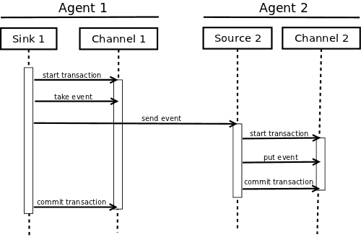

Fig. showing sink and source agents and flow of data

1. SQOOP

*What is sqoop?*

When Big Data storages and analyzers such as MapReduce, Hive, Hbase, Cassandra, Pig, etc. of the Hadoop ecosystem came into picture, they required a tool to interact with the relational database servers for importing and exporting the Big Data residing in them. Here, Sqoop occupies a place in the Hadoop ecosystem to provide feasible interaction between relational database server and Hadoop’s HDFS.

Sqoop: “SQL to Hadoop and Hadoop to SQL”

Sqoop is a tool designed to transfer data between Hadoop and relational database servers. It is used to import data from relational databases such as MySQL, Oracle to Hadoop HDFS, and export from Hadoop file system to relational databases. It is provided by the Apache Software Foundation.

Where is Sqoop used?

Relational database systems are widely used to interact with the traditional business applications. So, relational database systems has become one of the sources that generate Big Data.

As we are dealing with Big Data, Hadoop stores and processes the Big Data using different processing frameworks like MapReduce, Hive, Hbase, Cassandra, Pig etc and storage frameworks like HDFS to achieve benefit of distributed computing and distributed storage. In order to store and analyze the Big Data from relational databases, Data need to be transferred between database systems and Hadoop Distributed File System (HDFS). Here, Sqoop comes into picture. Sqoop acts like a intermediate layer between Hadoop and relational database systems. You can import data and export data between relational database systems and Hadoop and its eco-systems directly using sqoop.

*What Sqoop Does?*

Apache Sqoop does the following to integrate bulk data movement between Hadoop and structured datastores:

| **Function** | **Benefit** |
| --- | --- |
| Import sequential datasets from mainframe | Satisfies the growing need to move data from mainframe to HDFS​ |
| Import direct to ORCFiles | ​Improved compression and light-weight indexing for improved query performance |
| Data imports | Moves certain data from external stores and EDWs into Hadoop to optimize cost-effectiveness of combined data storage and processing |
| Parallel data transfer | For faster performance and optimal system utilization |
| Fast data copies | From external systems into Hadoop |
| Efficient data analysis | Improves efficiency of data analysis by combining structured data with unstructured data in a schema-on-read data lake |
| Load balancing | Mitigates excessive storage and processing loads to other systems |

Table function and benefit of sqoop

1. PIG

*What Is Pig*?

Pig is a high level scripting language that is used with Apache Hadoop. Pig enables data workers to write complex data transformations without knowing Java. Pig’s simple SQL-like scripting language is called Pig Latin, and appeals to developers already familiar with scripting languages and SQL.

Pig is complete, so you can do all required data manipulations in Apache Hadoop with Pig. Through the User Defined Functions(UDF) facility in Pig, Pig can invoke code in many language like Java. You can also embed Pig scripts in other languages. The result is that you can use Pig as a component to build larger and more complex applications that tackle real business problems.

To write data analysis programs, Pig provides a high-level language known as Pig Latin. This language provides various operators using which programmers can develop their own functions for reading, writing, and processing data.

To analyze data using Apache Pig, programmers need to write scripts using Pig Latin language. All these scripts are internally converted to Map and Reduce tasks. Apache Pig has a component known as Pig Engine that accepts the Pig Latin scripts as input and converts those scripts into MapReduce jobs.

*Features of Pig*

Apache Pig comes with the following features –

* **Rich set of operators** – It provides many operators to perform operations like join, sort, filer, etc.
* **Ease of programming** – Pig Latin is similar to SQL and it is easy to write a Pig script if you are good at SQL.
* **Optimization opportunities** – The tasks in Apache Pig optimize their execution automatically, so the programmers need to focus only on semantics of the language.
* **Extensibility** – Using the existing operators, users can develop their own functions to read, process, and write data.
* **UDF’s** – Pig provides the facility to create **User-defined Functions** in other programming languages such as Java and invoke or embed them in Pig Scripts.
* **Handles all kinds of data** – Apache Pig analyzes all kinds of data, both structured as well as unstructured. It stores the results in HDFS.

*Pig UDF’s:*

In addition to the built-in functions, Apache Pig provides extensive support for User Defined Functions (UDF’s). Using these UDF’s, we can define our own functions and use them. The UDF support is provided in six programming languages, namely, Java, Jython, Python, JavaScript, Ruby and Groovy.

For writing UDF’s, complete support is provided in Java and limited support is provided in all the remaining languages. Using Java, you can write UDF’s involving all parts of the processing like data load/store, column transformation, and aggregation. Since Apache Pig has been written in Java, the UDF’s written using Java language work efficiently compared to other languages.

In Apache Pig, we also have a Java repository for UDF’s named Piggybank. Using Piggybank, we can access Java UDF’s written by other users, and contribute our own UDF’s

Types of UDF’s in Java:

While writing UDF’s using Java, we can create and use the following three types of functions –

* **Filter Functions** – The filter functions are used as conditions in filter statements. These functions accept a Pig value as input and return a Boolean value.
* **Eval Functions** – The Eval functions are used in FOREACH-GENERATE statements. These functions accept a Pig value as input and return a Pig result.
* **Algebraic Functions** – The Algebraic functions act on inner bags in a FOREACHGENERATE statement. These functions are used to perform full MapReduce operations on an inner bag.

**Step I: Flume**

We have used flume to place the data into HDFS. For that first we have created the directory /project using the command

Hadoop fs –mkdir /project.

Then used the following conf file to provide the configuration and the path to store the data into the HDFS.

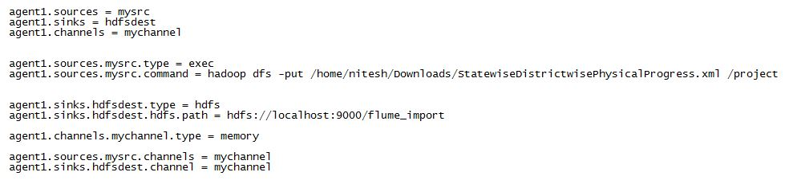

The above conf file is used to specify the path of the sink and the source also the channels are also set in this file.

Once the directory is made and conf file is set then the flume command is executed

Flume-ng agent -n agent1 –conf –f <path of conf file>

Exection of the command is shown in below screen shots:

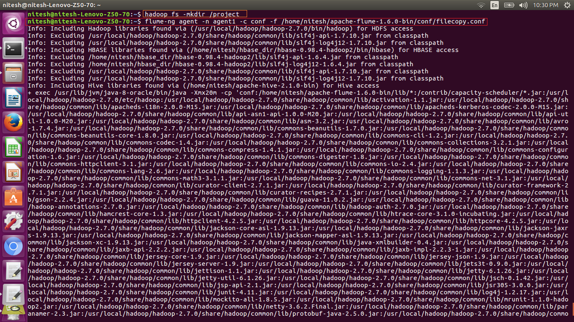

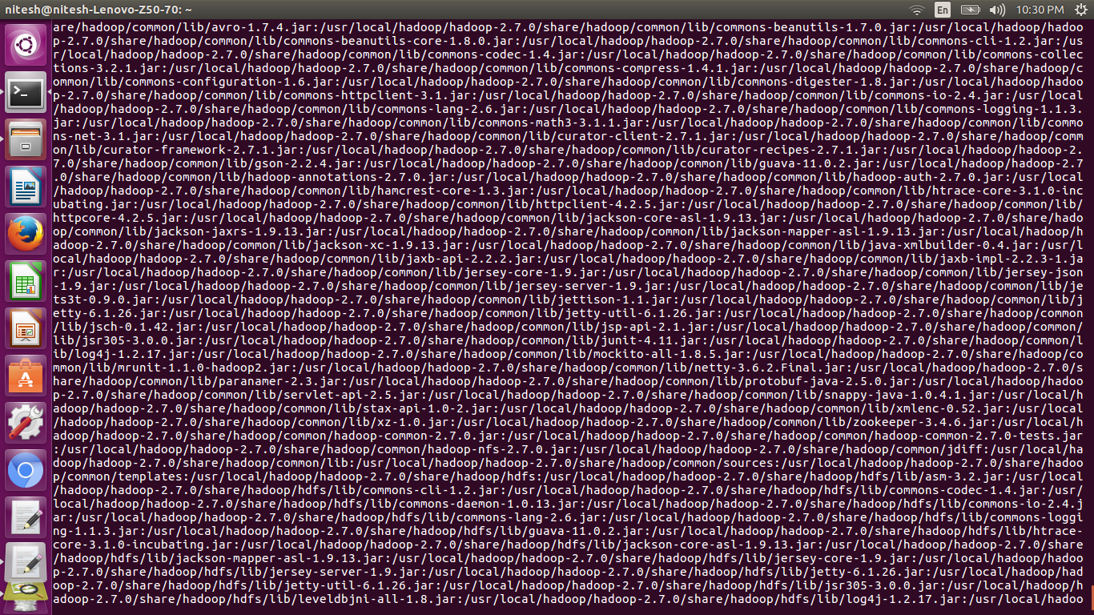

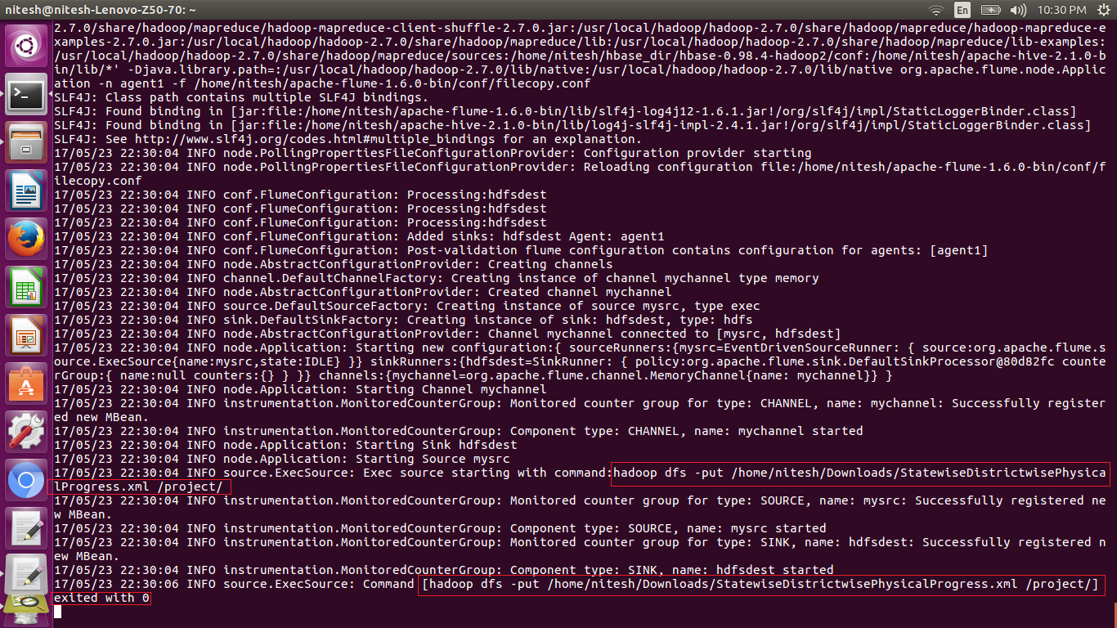

In the above screen shot we can see in the first red bock the command to put in the hdfs and then we can find the file is written in the specified folder.

Here we can see the file is written in the specified folder as we use the ls command to locate the file in the specified folder then using the cat command for authenticity.

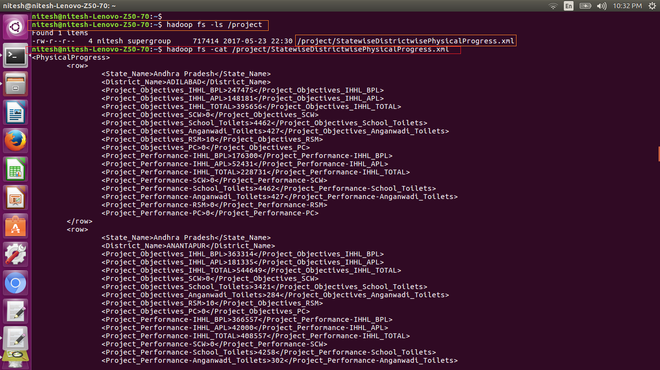

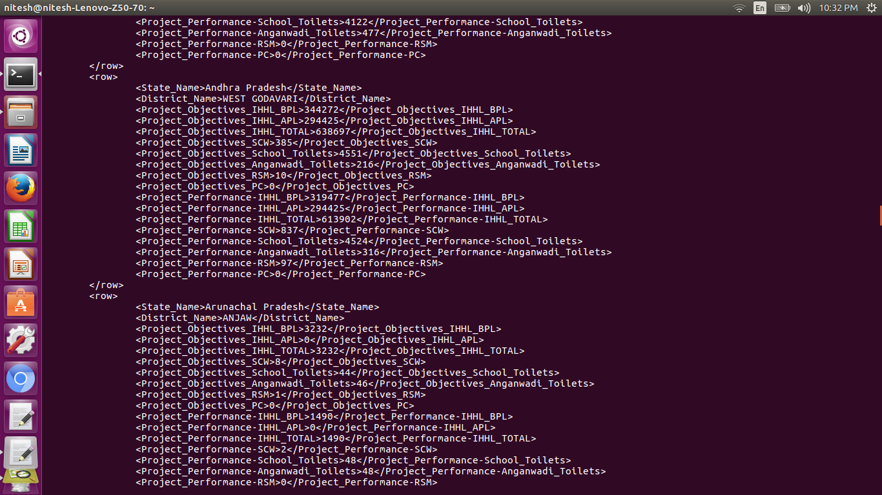

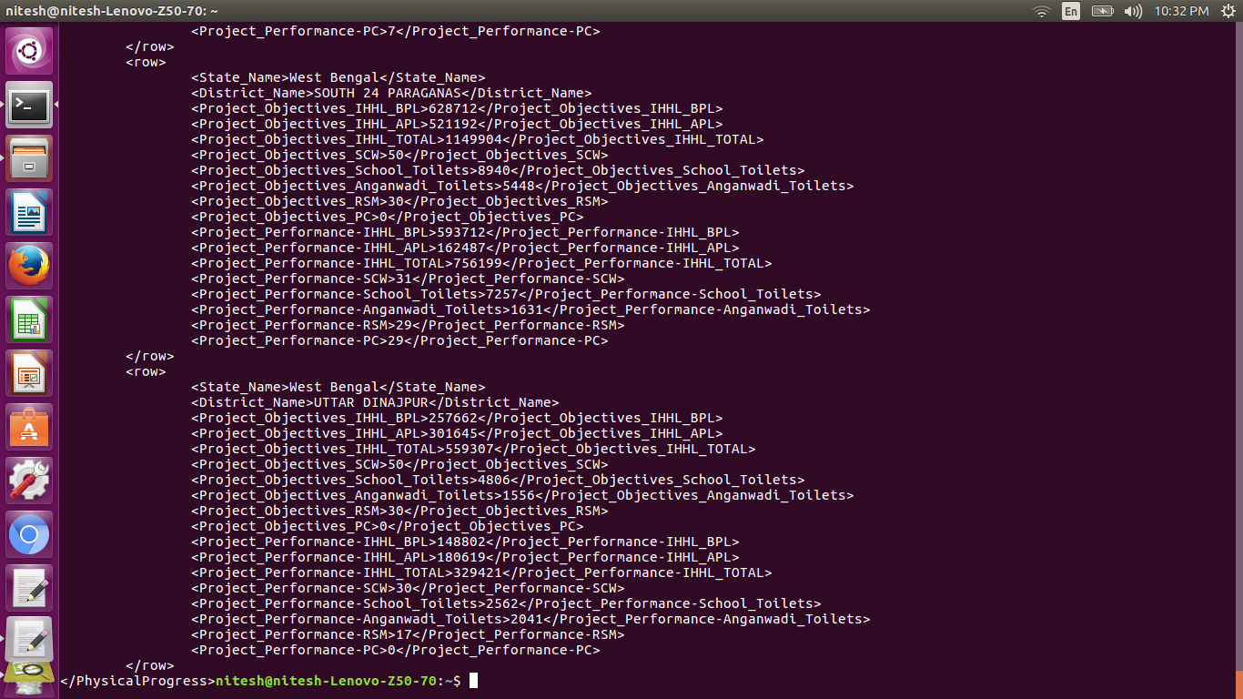

The above screen shots show the data is written using flume command in the hdfs. The data is in the xml format.

**Step II: Conversion of xml file to csv file using the pig script**

Here we have the xml file in the hdfs from the first step.

The file is loaded in the variable ‘A’

Using variable ‘B’ we replaced the new line by ‘,’

In variable ‘C’ we have removed the tags and the information is fetched such as <State_Name> is removed to get the name of the state only.

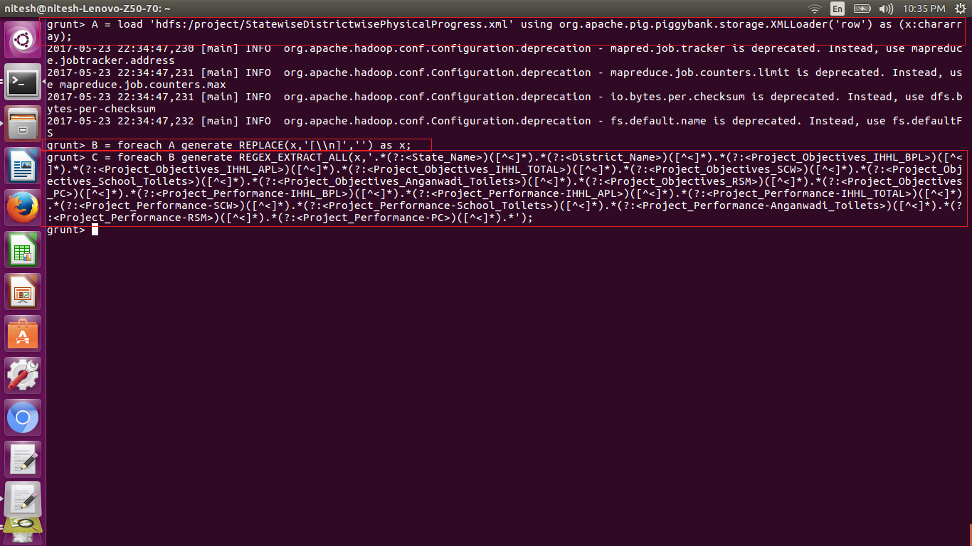

After that we used the store command to store the converted file into the desired location as we have stored it in the ‘/pig_conversion/xml_to_csv’ by specifying hdfs: before the path means the described path is of hdfs.

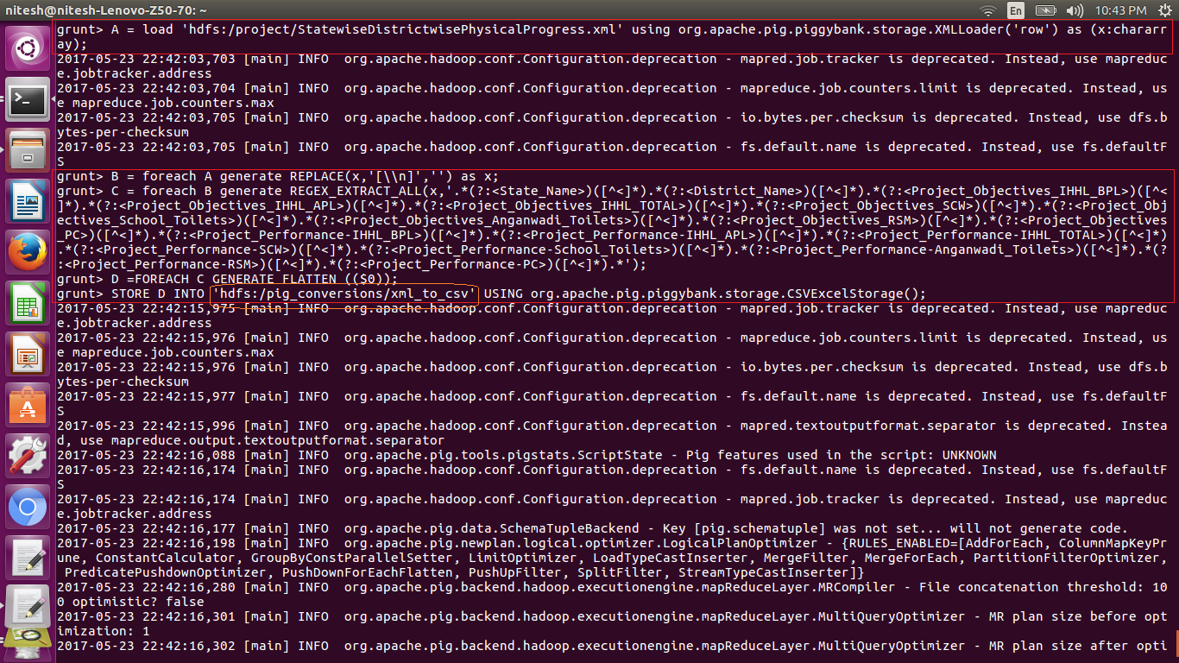

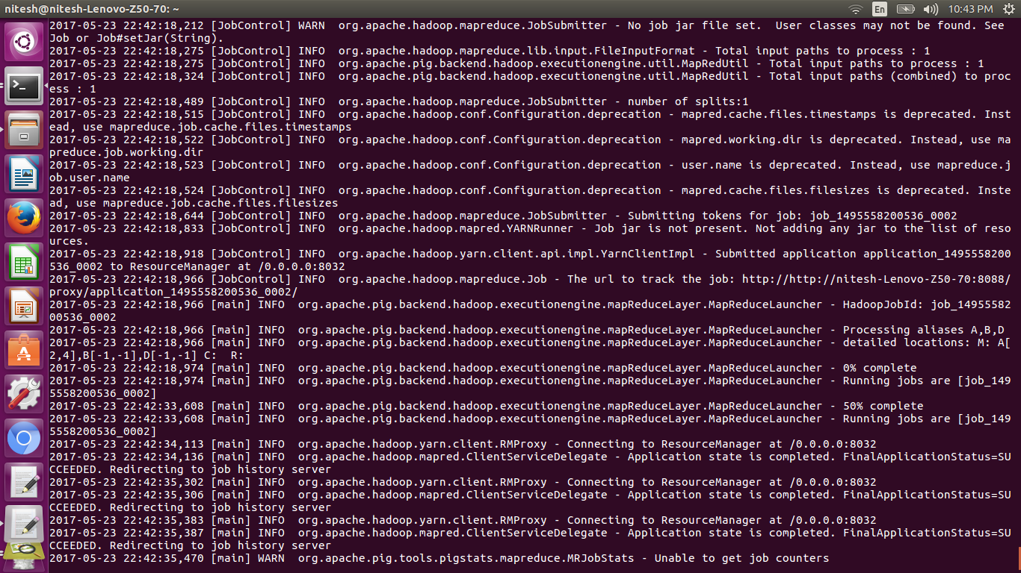

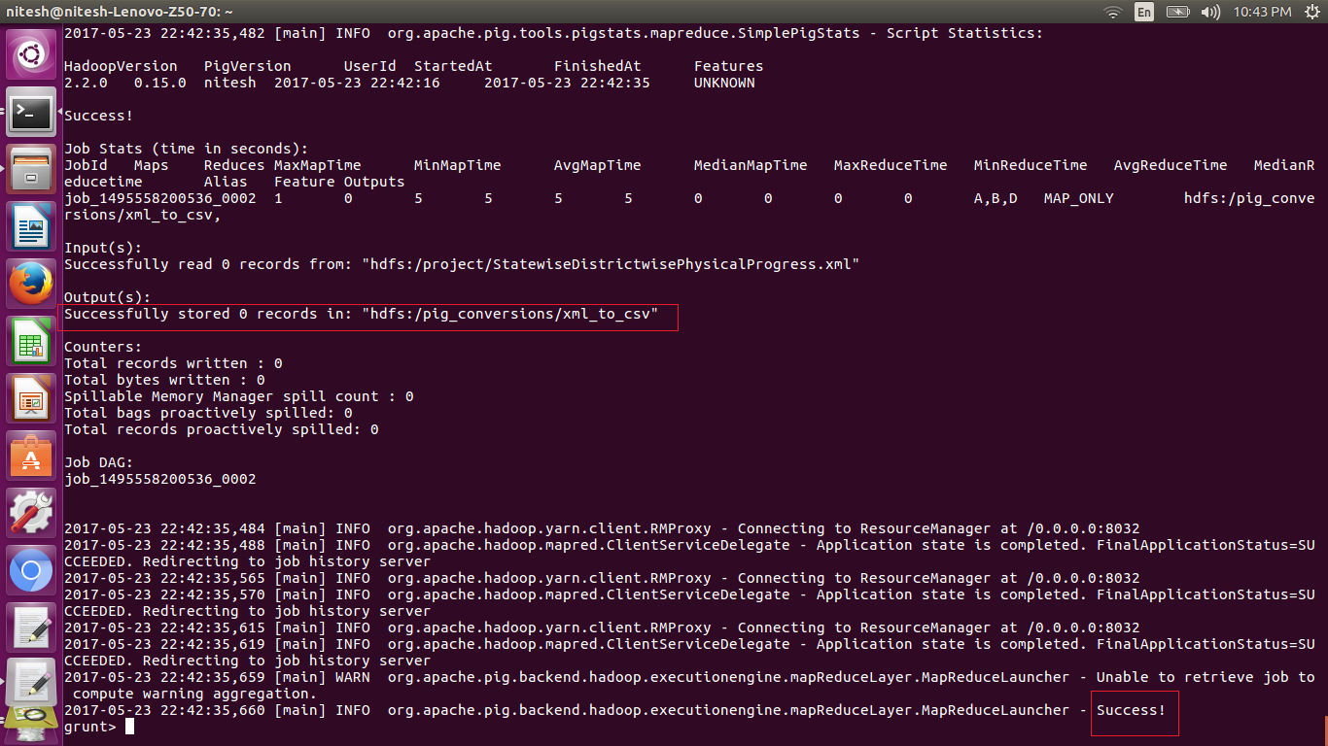

The above screen shot show that the csv file(converted from the xml) is stored successfully as we can see in the red blocks.

The file is stored as the part-m-00000 in the given path as we can seen in the below screen shots:

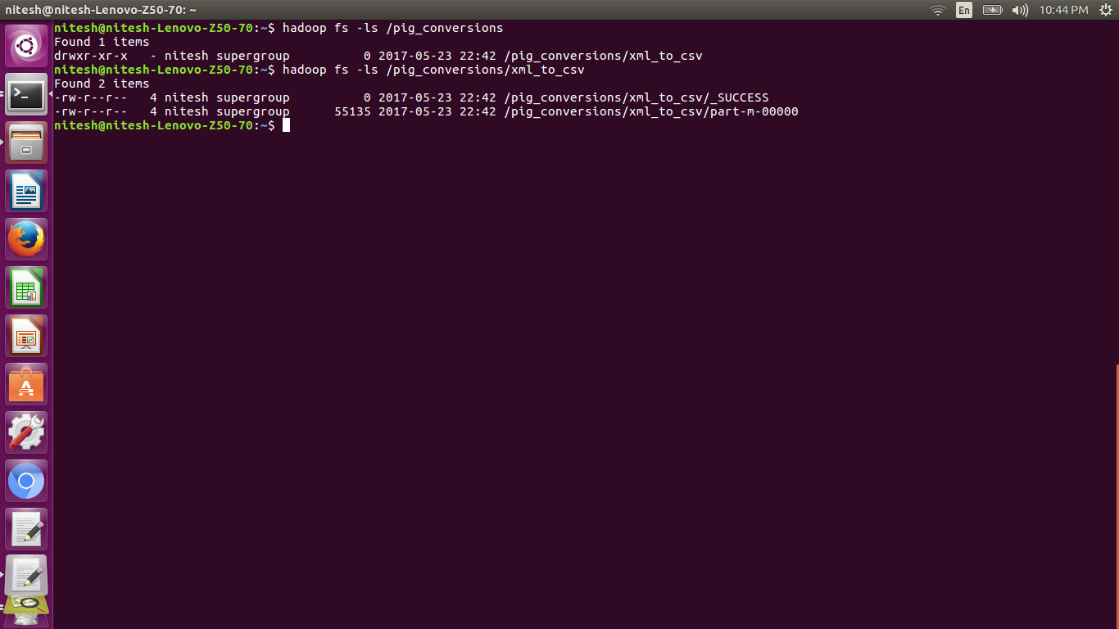

Here we have performed cat command on the stored file to check if we got the desired converted file.

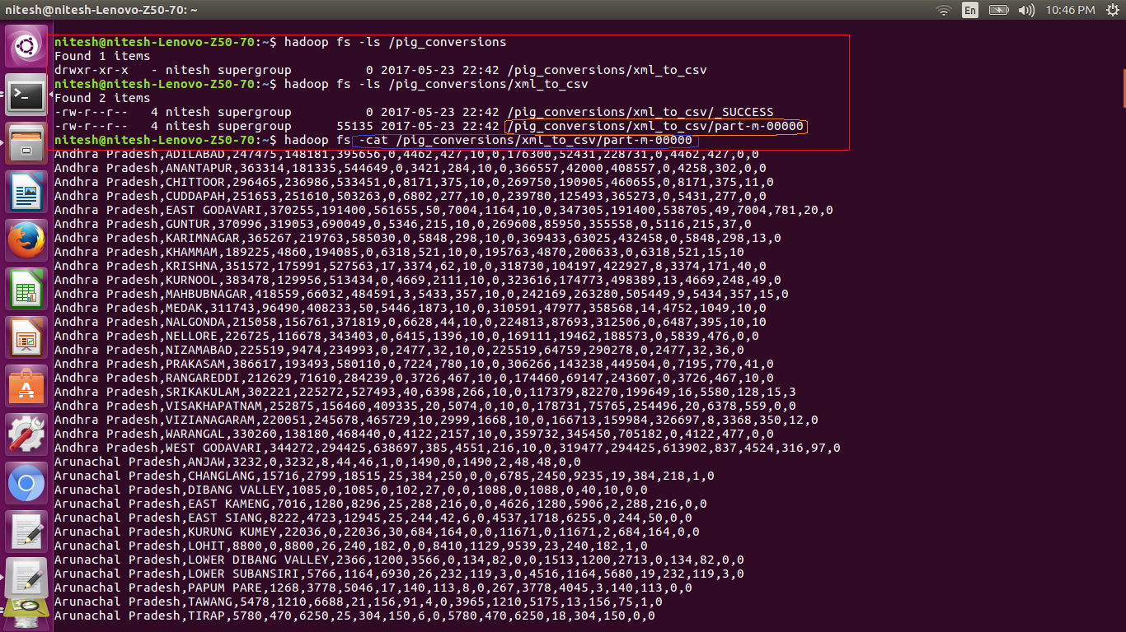

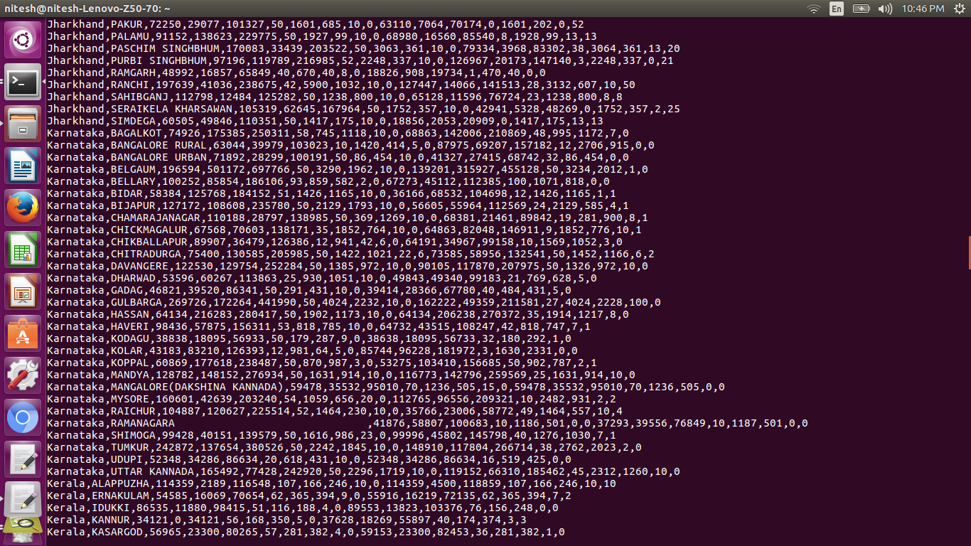

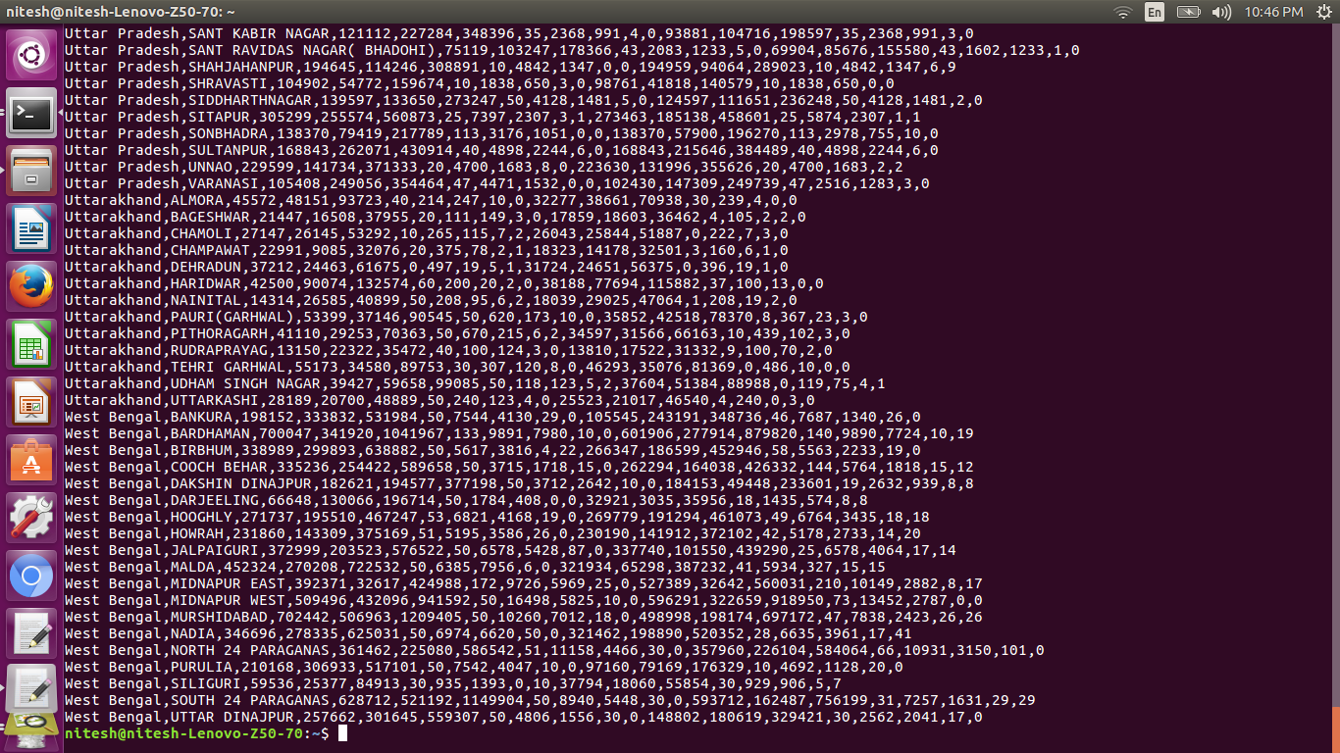

As we can see from the above screen shots the output is the desired one .i.e. comma separated values and tags are deleted.

**UDF**

User Defined Function(UDF’s) are the functions that programmer define for the purpose to be achieved.

Here we have defined two UDF’s one to fetch the percentage and the other one to filter the data on the basis of the achieved performance percentage.

Percent UDF:

Steps:

1. We have extended class to the EvalFunc which is used to generate the desired output same as the avg,sum,etc.
2. The two arguments are passed to this udf and the percentage is calculated and returned
3. The first input is stored in str and converted to string similarly for the second we used the variable str1.
4. Both the str and str1 variables are now parsed to integer and the percentage is calculated.
5. The percentage is stored in the float variable and the return type of this udf is float. So we get the percentage in the float datatype.

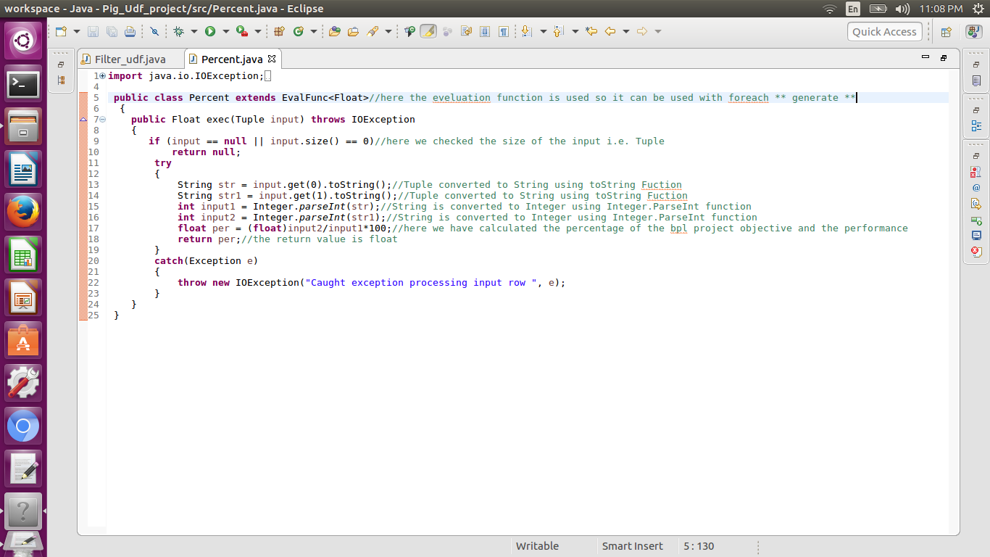

Here we have a filter udf which is used to filter the data for the condition we want.

Steps

1. Here the class is extended to the FilterFunc and the return type of the udf is Boolean.
2. This udf have two arguments passed and the logic to check whether the performance have achieved 80% or not.
3. If 80% is achieved then return value is true else false
4. This udf is implemented in the filter function of the pig script to filter the data on the basis of the percentage achieved in reference to the objective.

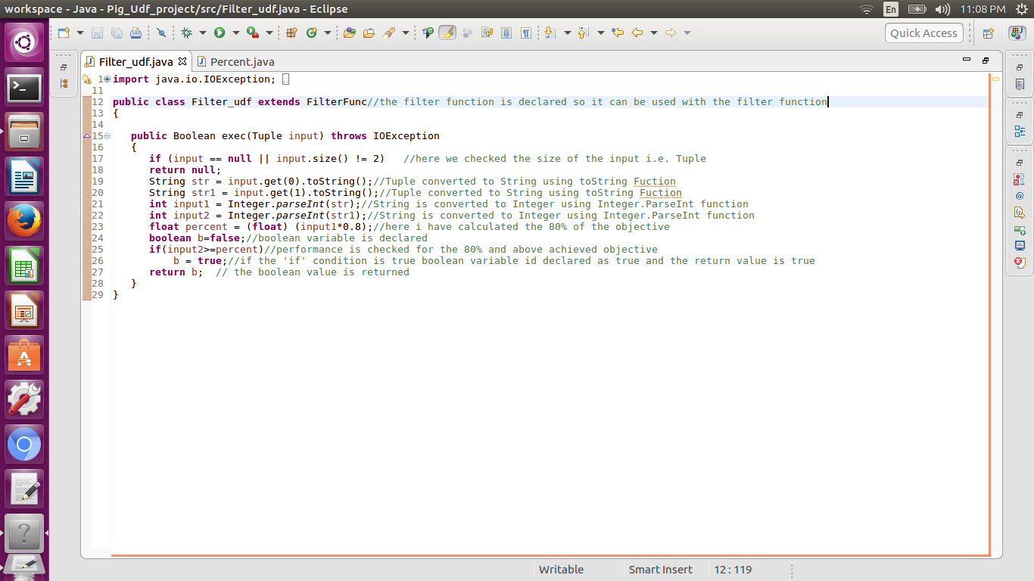

**Problem statement 1**

Find out the districts who achieved 100 percent objective in BPL cards Export the results to mysql using sqoop

Answer:

The first problem statement is to fetch the districts who achieved 100% in BPL cards and export the result in the mysql using sqoop.

Here we have implemented the logic to fetch the data for exact 100% achieved and we have stored state, district and percentage.

1. The udfs are used to create the jar and the created jar are registered using the command register
2. We have registered both the jars to fetch the percentage and to filter by calculating percentage percent.jar and filter_udf.jar respectively.

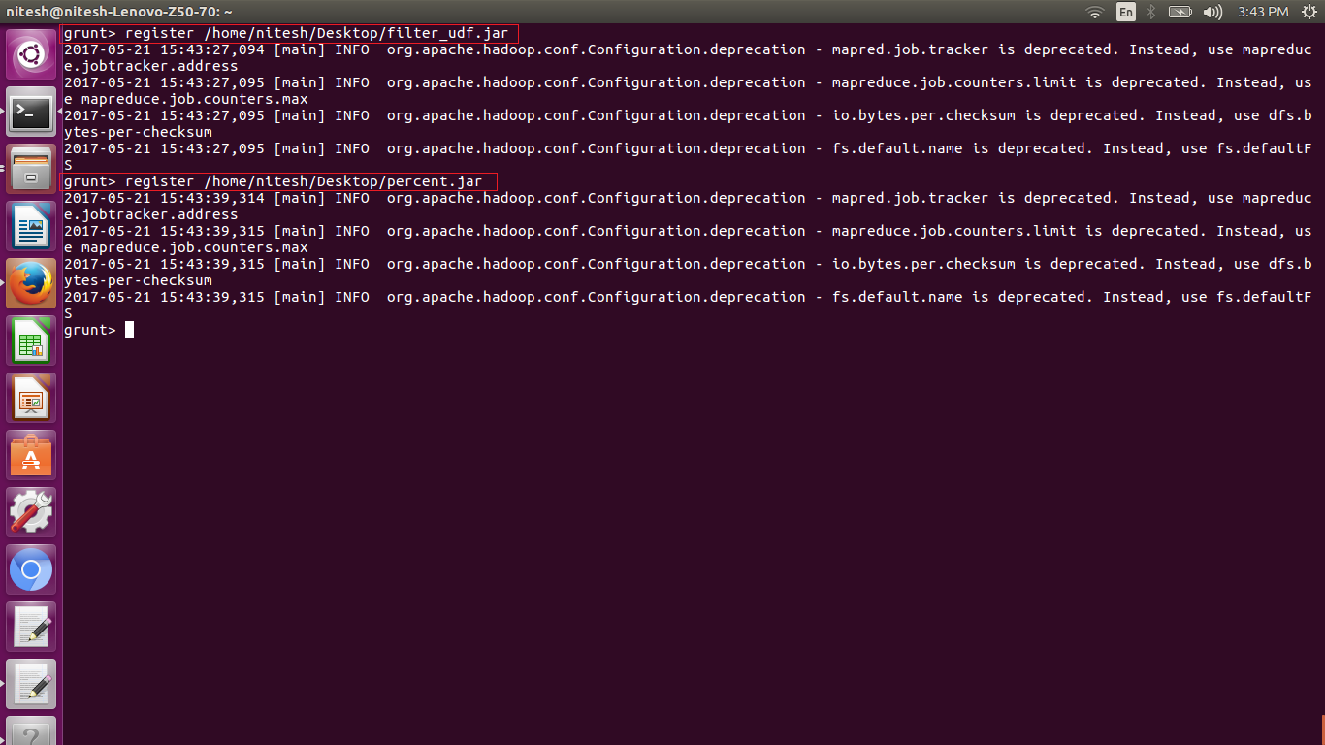

1. Now as we have registered jars we need to load the data set in the variable Input_data.

2. Loading of data is done using the following command

load ‘hdfs:input path’ Using PigStorage(‘delimiter’) as (variable:datatype);

1. After the dataset is loaded in Input_data variable we have applied filter fuction so we can filter the loaded data to fetch the data which is exactly 100% using

filter ‘dataset’ BY condition;

1. Once the filter operation is done we need to generate the columns to be stored using following syntax

foreach ‘filtered data‘ generate state,district,percent;

1. The required columns are generated and now we need to store the data into the hdfs so we use

store ‘generated data’ into ‘path’ using org.apache.pig.piggybank.storage.CSVExelStorage();

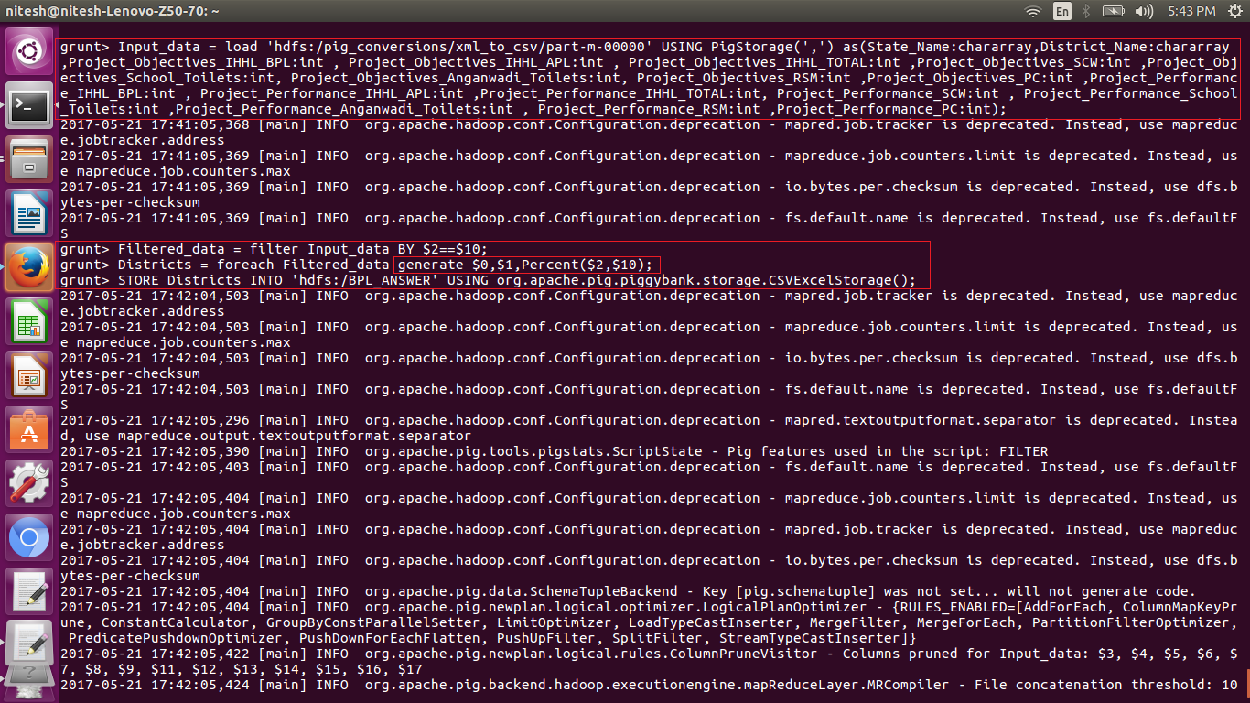

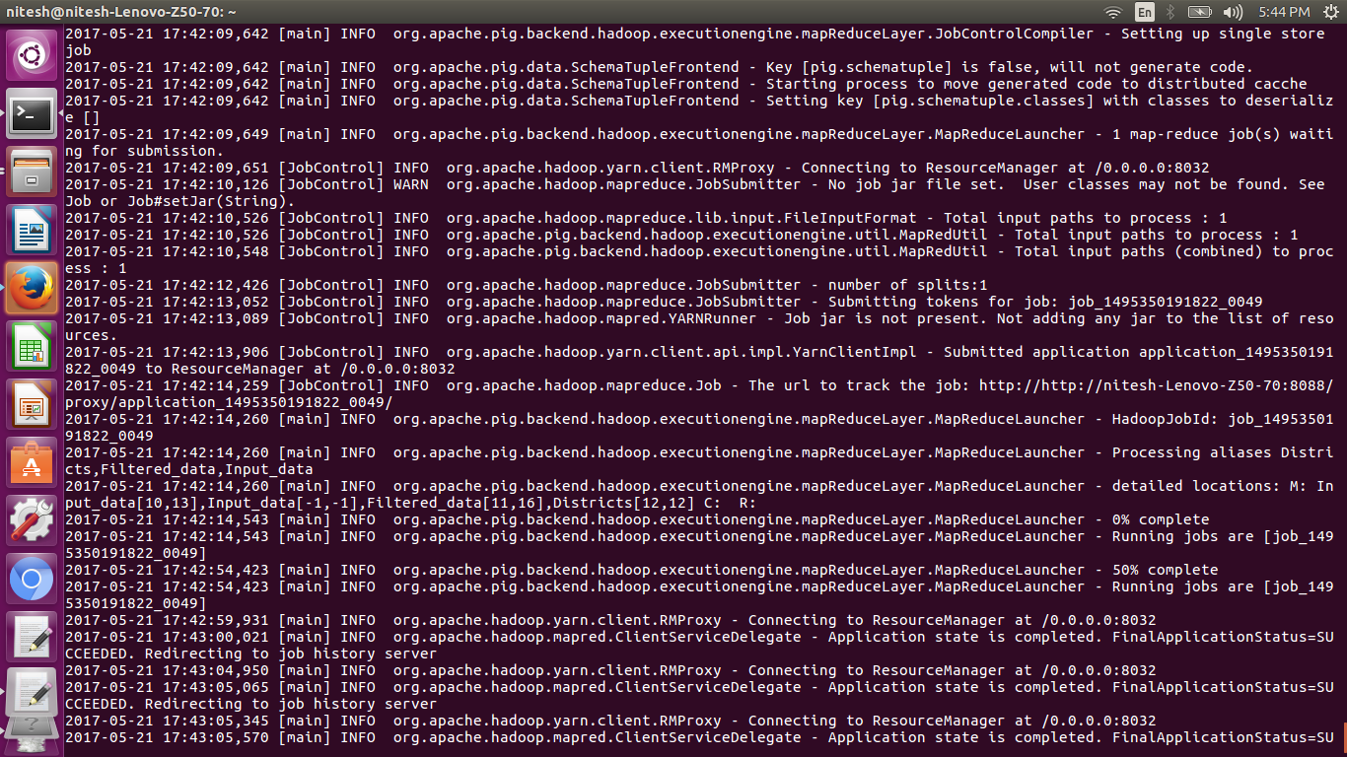

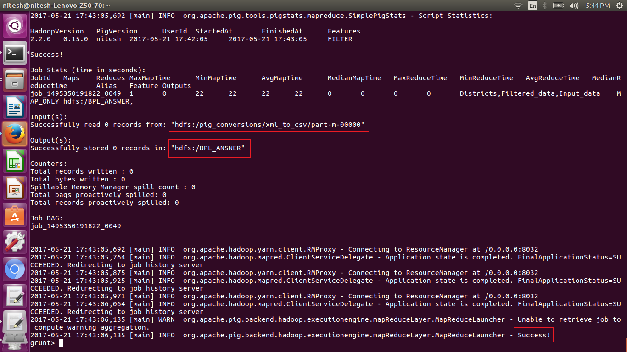

6. When the store command is executed the dataset are written in the specified directory as we can see in the above screen shot.

1. The stored data can be seen in the hdfs so we use

adoop fs –ls ‘/stored path’ here we highlighted using the red box as shown below.

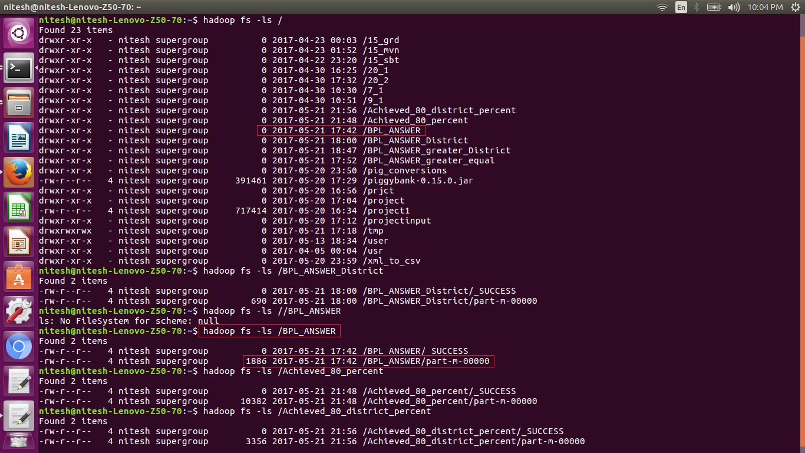

8. Now as we need to export the data into the mysql, we need to create a database, to create table, in which the stored dataset from hdfs can be loaded to the mysql.

9. The below screen shot shows the creation of the database and the table

for that purpose we have used the following commands

create database ‘database name’

a. use ‘database name’

b. create table ‘table name’ (columns:data type)

we have also described the table as shown in the below picture

using the command describe table

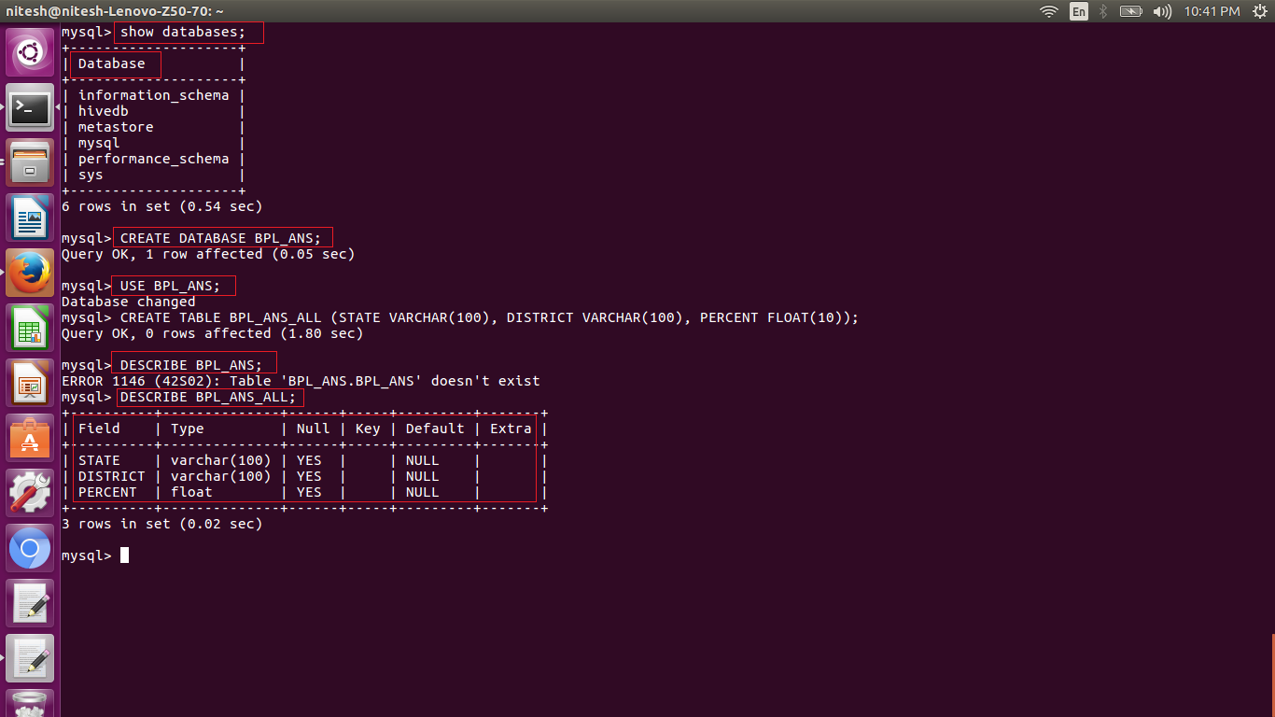

10. Now as we have generated the table in mysql we can export the data from the hdfs to mysql using sqoop. The following is the command to do so

sqoop export –m 1 – connect jdbc:mysql://localhost:3306/’database name’ –username username –password password –table ‘table name’ –export-dir ‘hdfs path of the file to be exported’ –driver com.mysql.jdbc.Driver

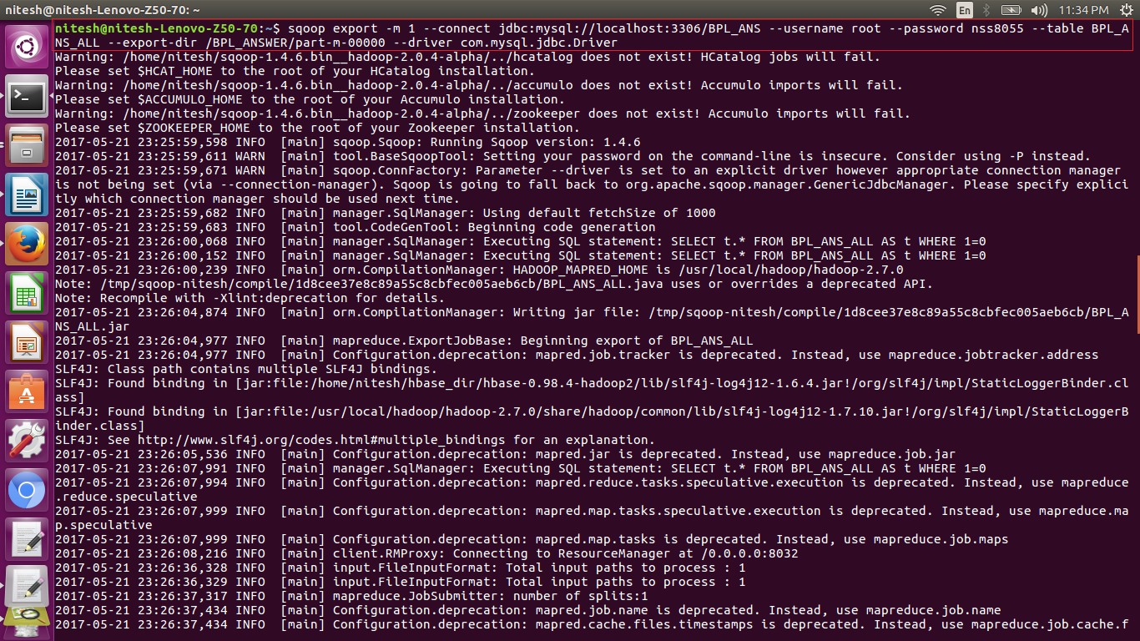

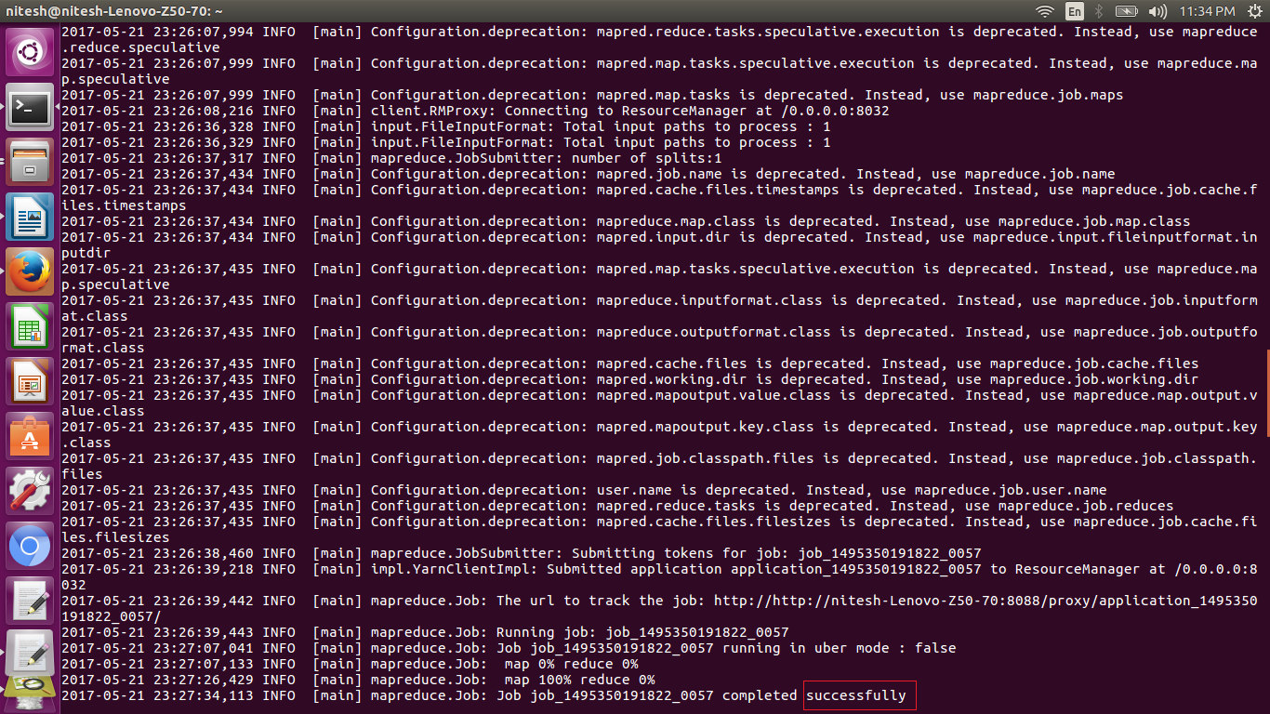

we can see that the sqoop command executed successfully as shown above in the picture and it is highlighted

11. Now we need to check if the required data is written in mysql, for that we logged into the mysql using command

mysql –u root –p

12. Now we need to use the database we created to create the table to store the data.

So we use the same database using

use ‘database’

show ‘tables’ will show the tables created in the database

to check if the data is loaded in the table we use the select query to verify

select * from ‘table name’

it will display all the entries in the table and we can see the required data is written from the hdfs to mysql using sqoop.

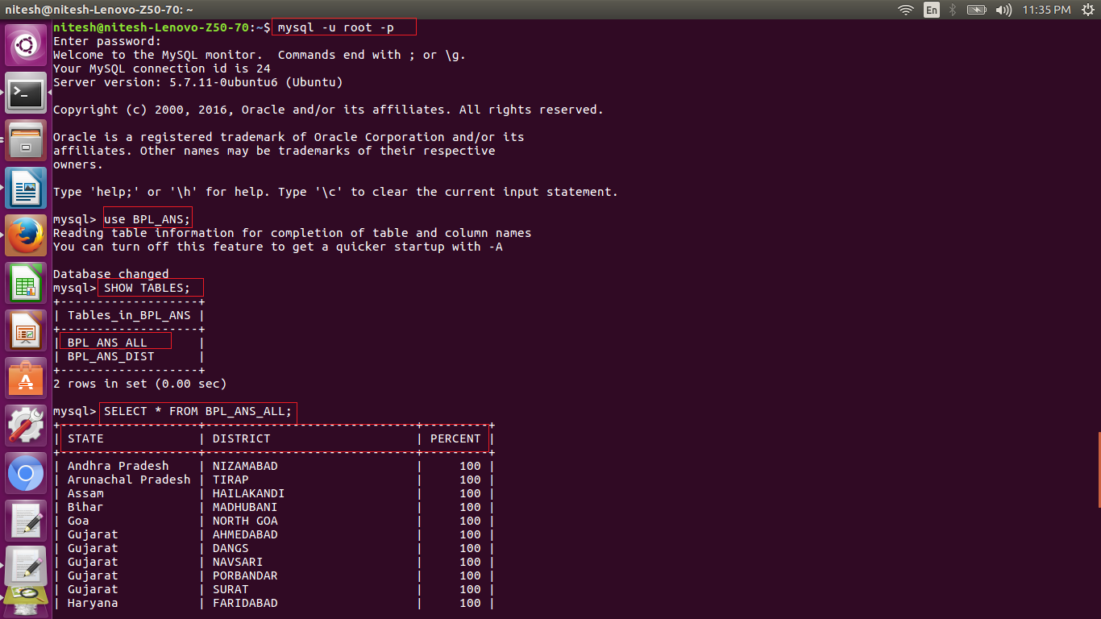

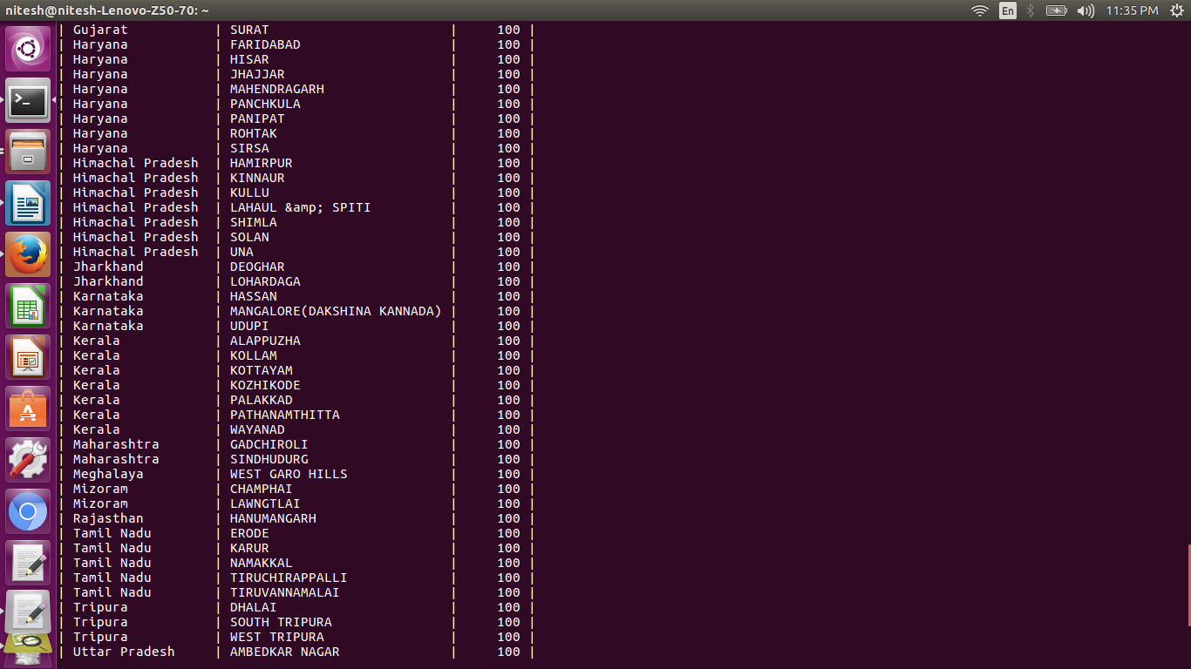

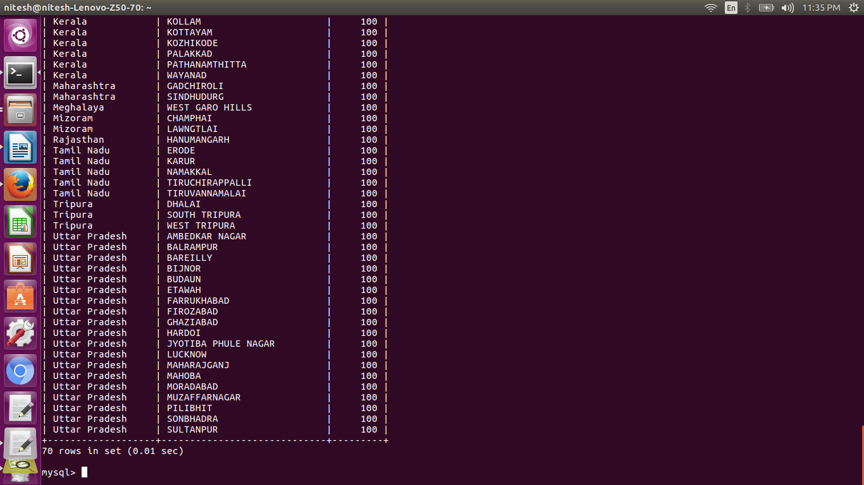

the above are the few screen shots of the answer

there are 70 entries of the exact 100%.

*Code is for exact 100% of performance reference to objective and displaying district only.*

Here we have done the same processes to get the data, but we fetched only districts to store in hdfs and then into the mysql using sqoop.

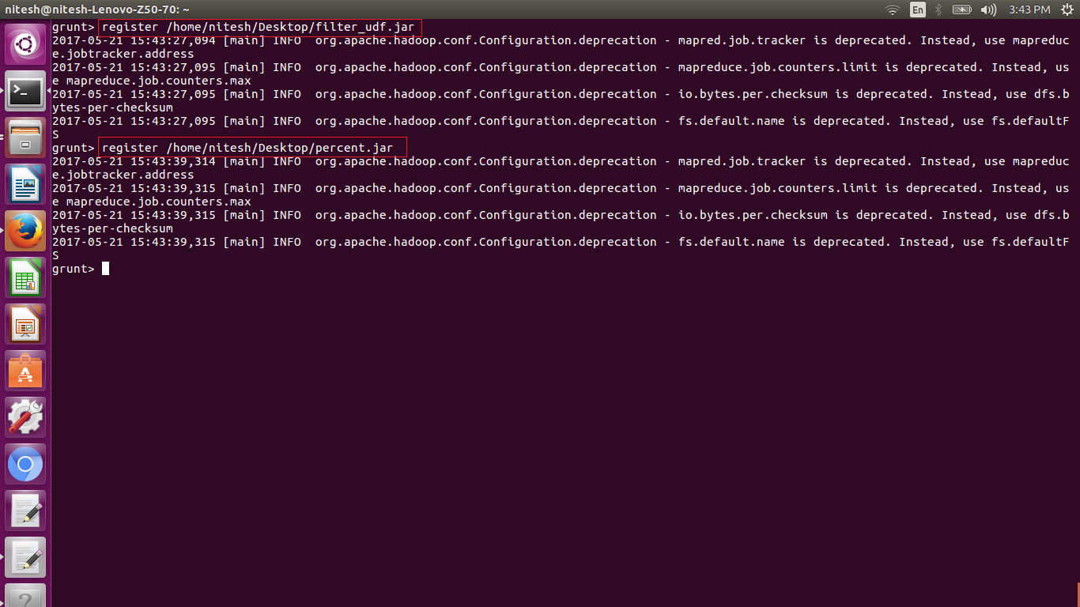

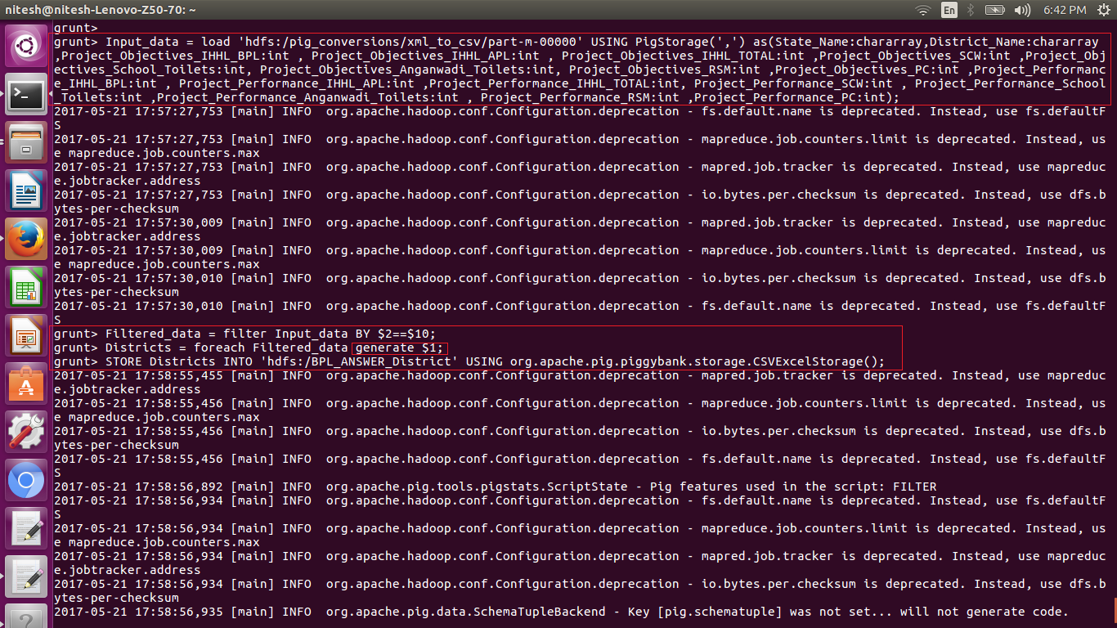

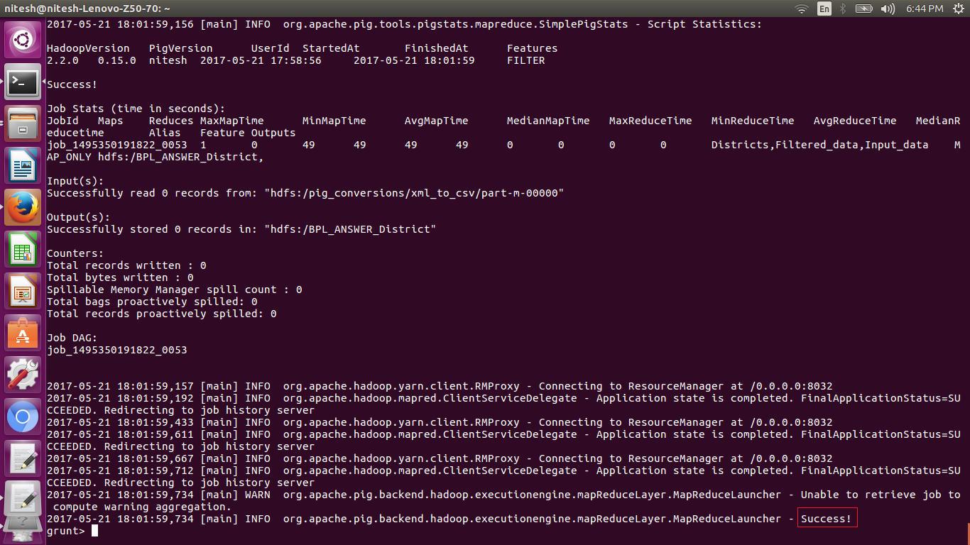

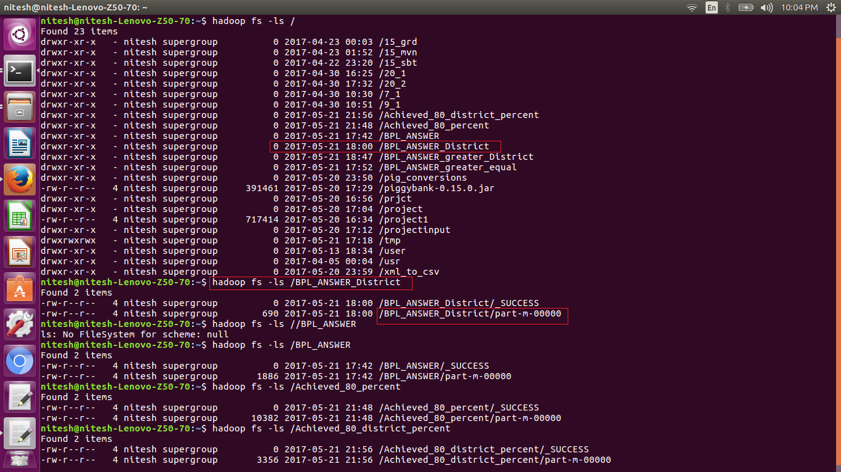

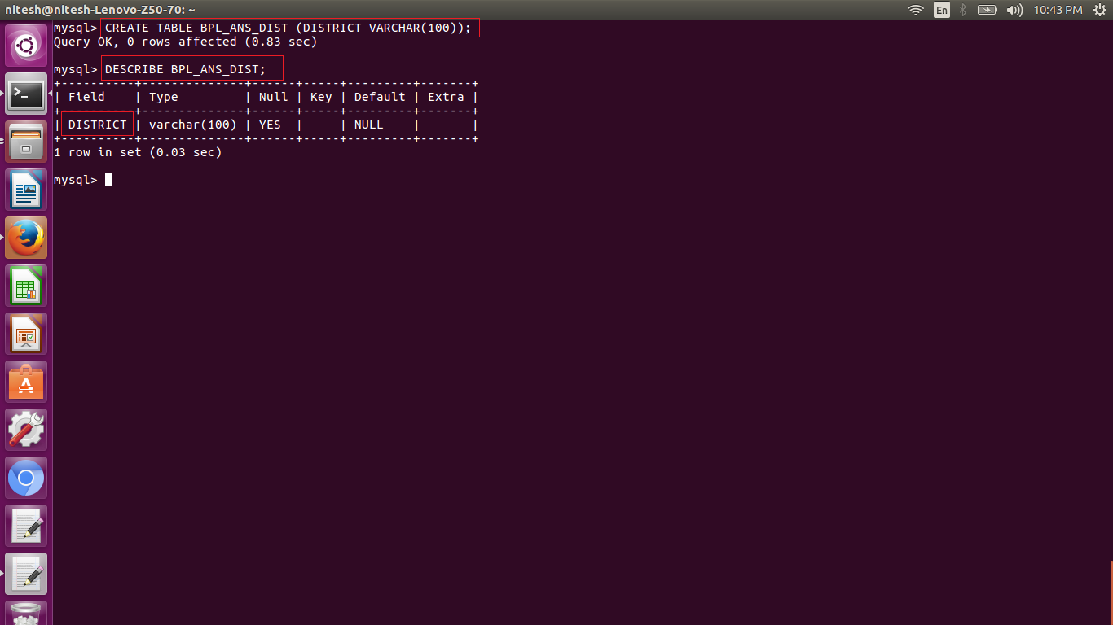

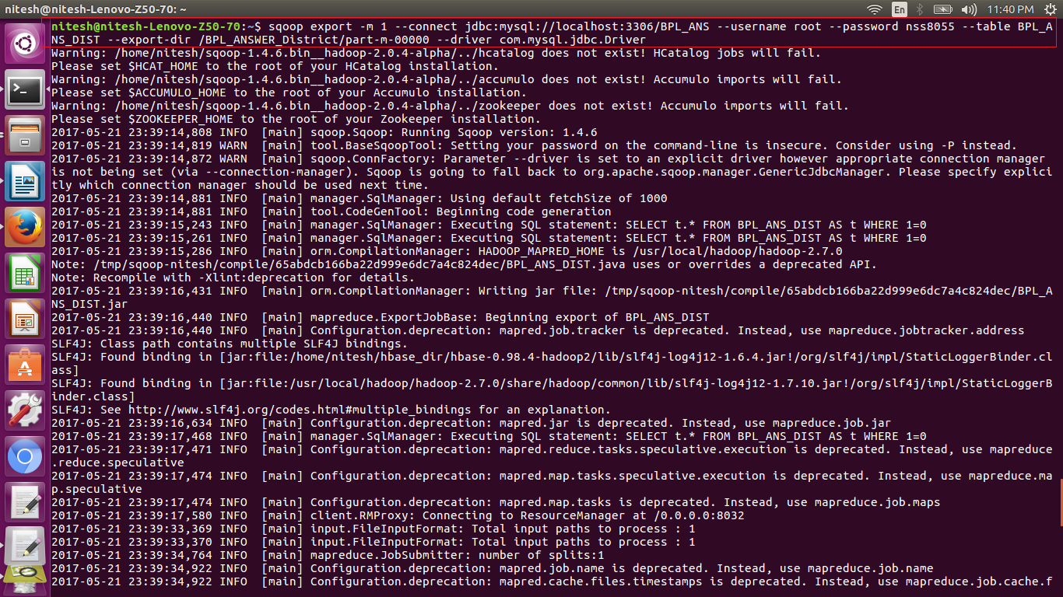

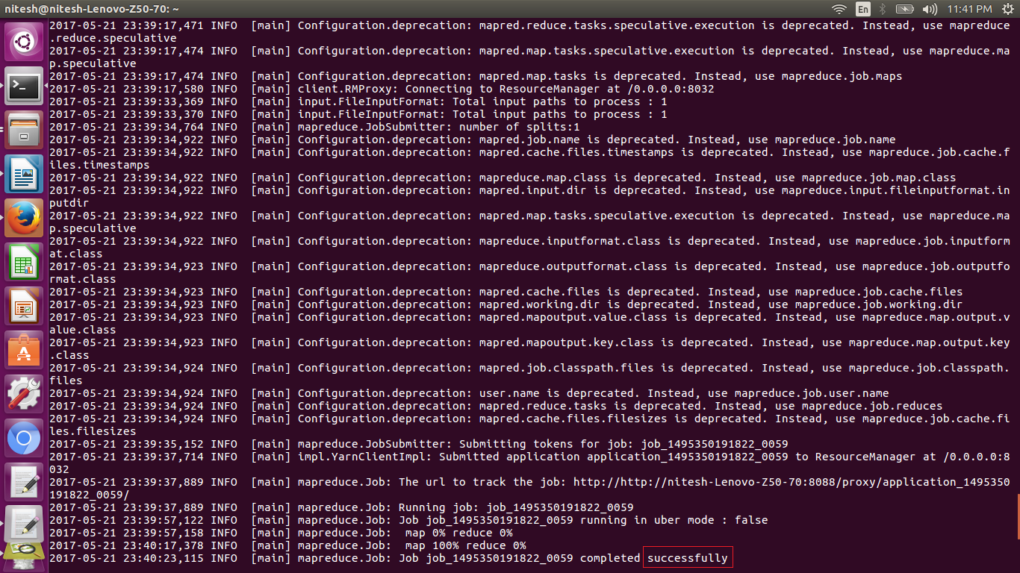

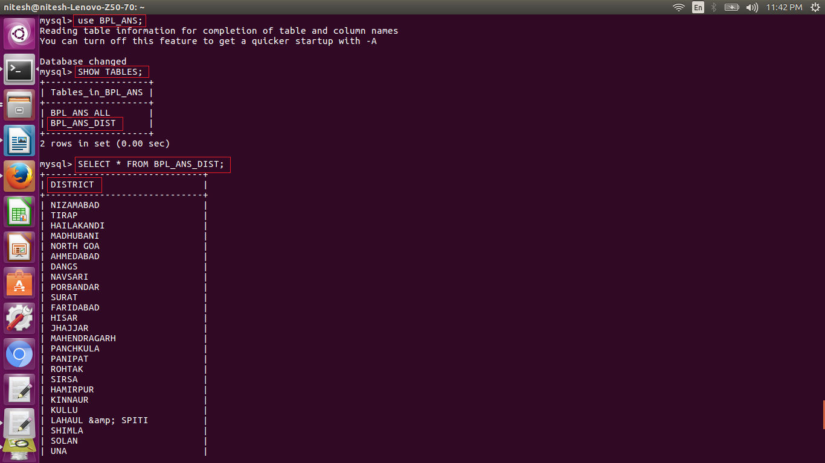

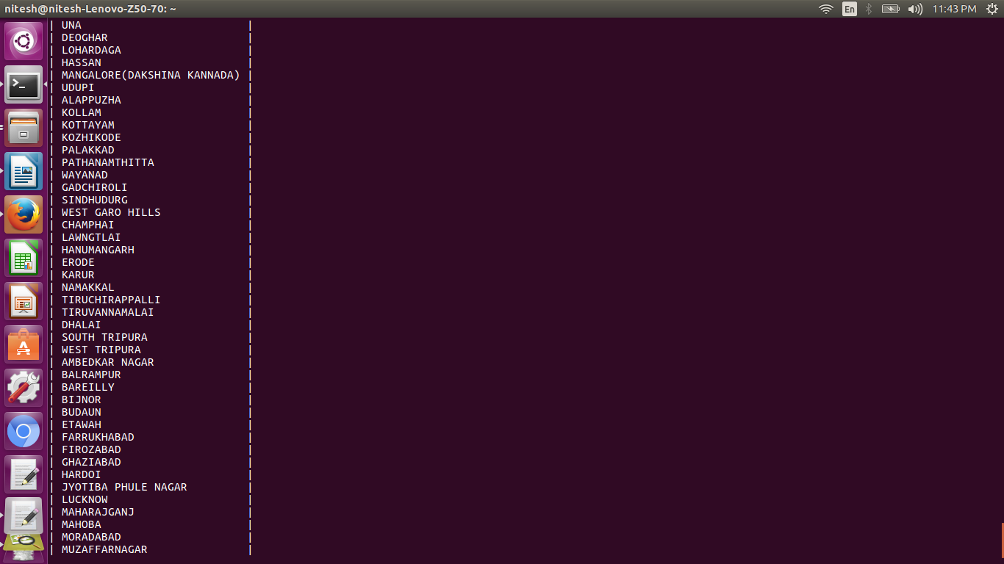

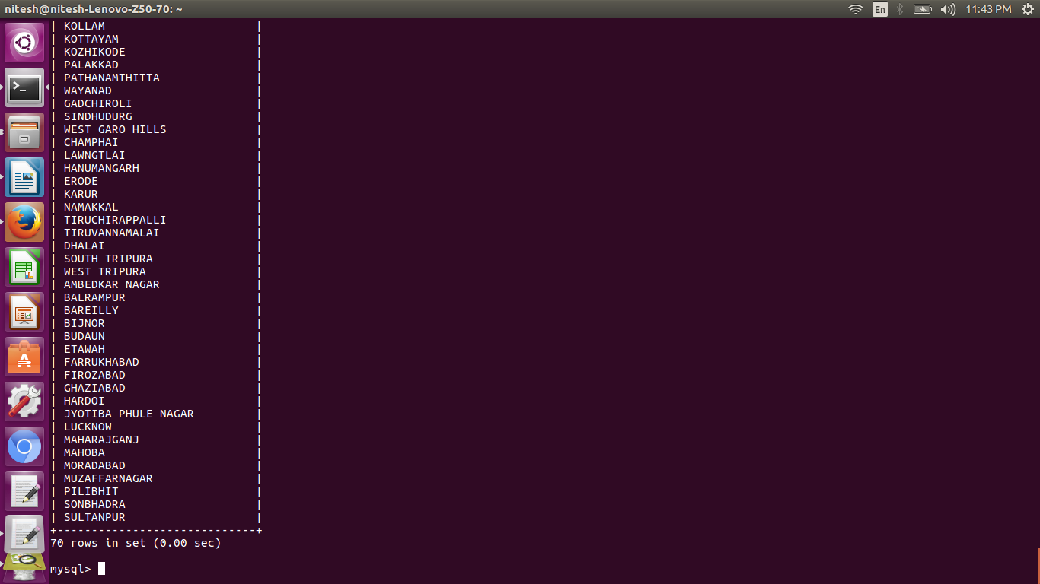

*Here we have a code for greater than or equal to 100% of performance in reference to objective and we have displayed all state, district and percentage.*

*Here we have done the same processes to get the data, and the data is stored in hdfs and then into the mysql using sqoop.*

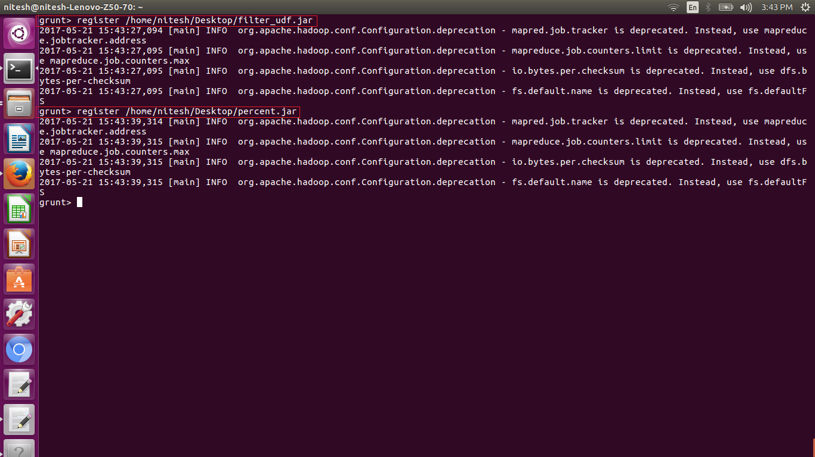

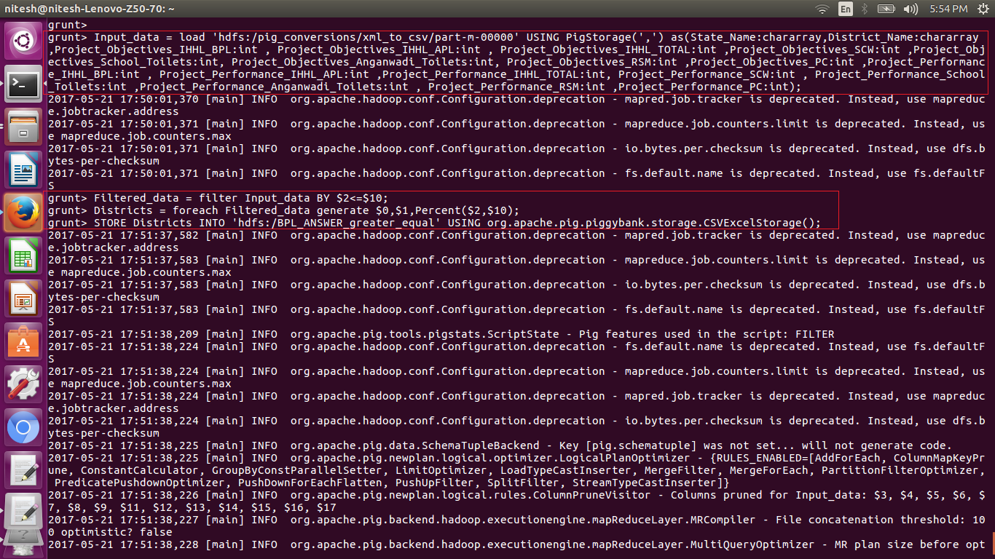

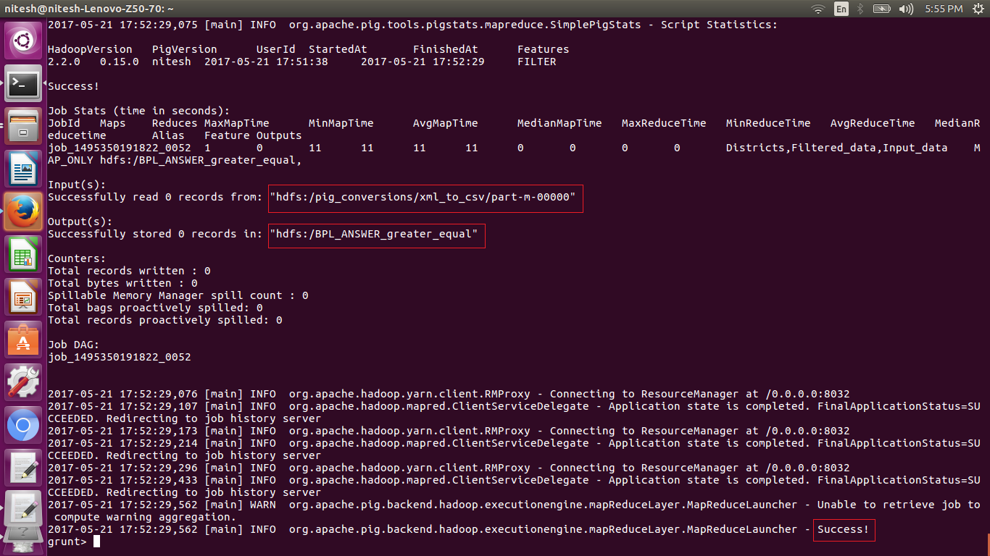

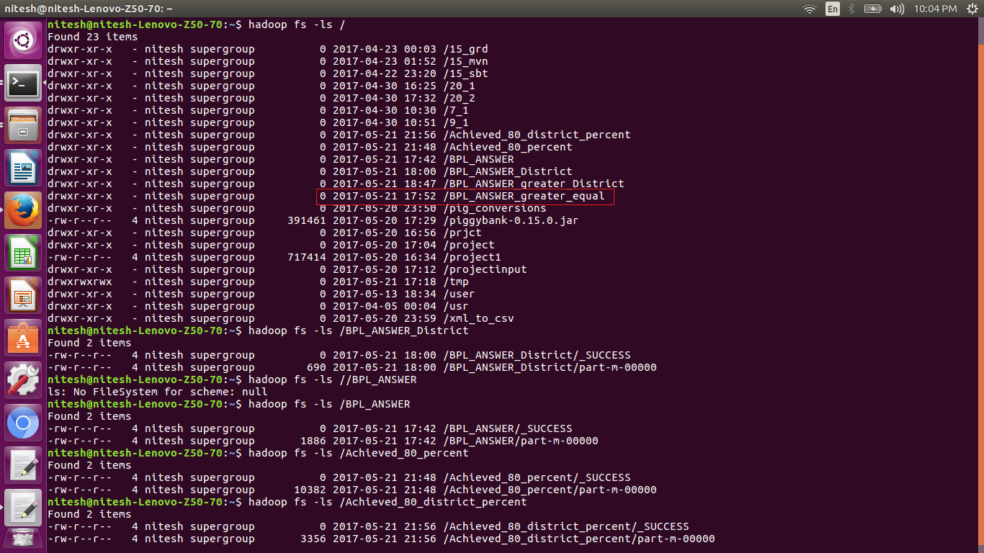

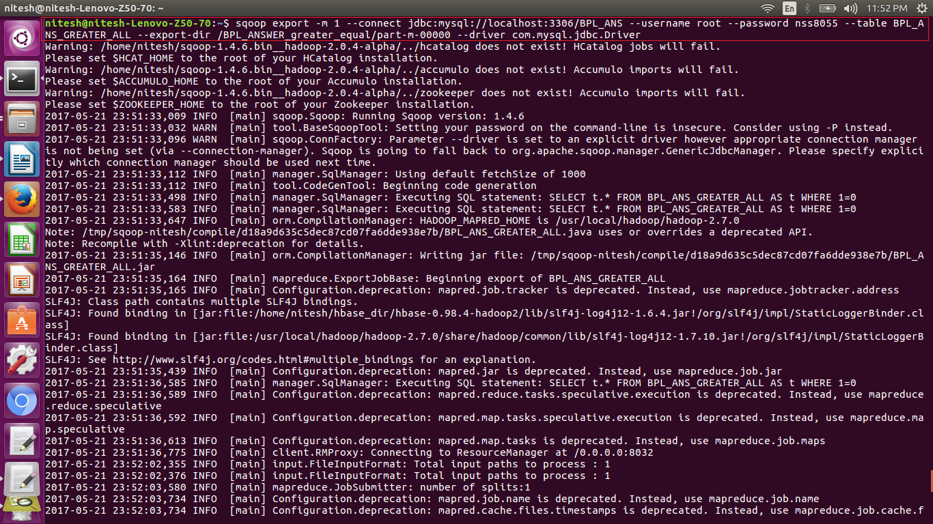

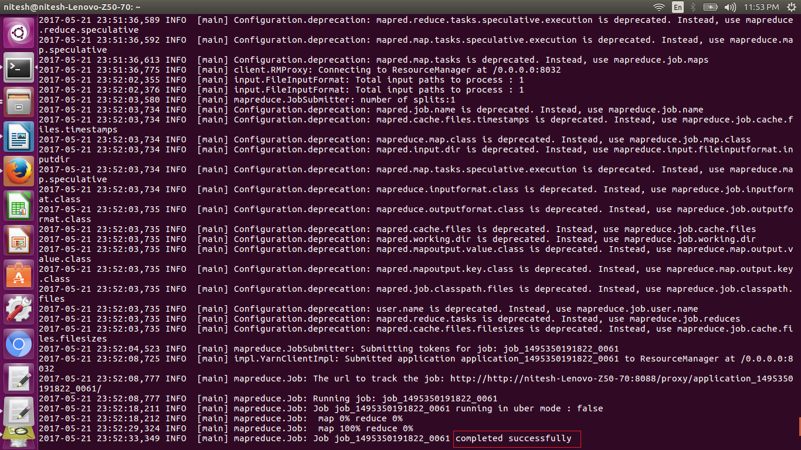

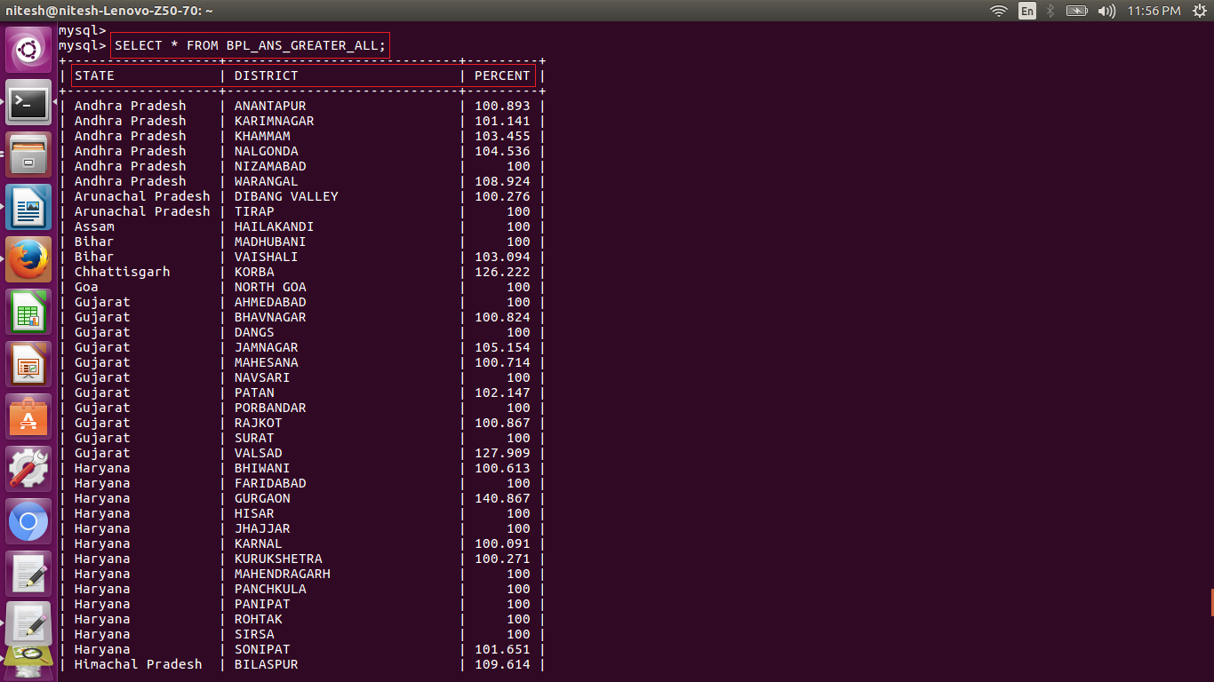

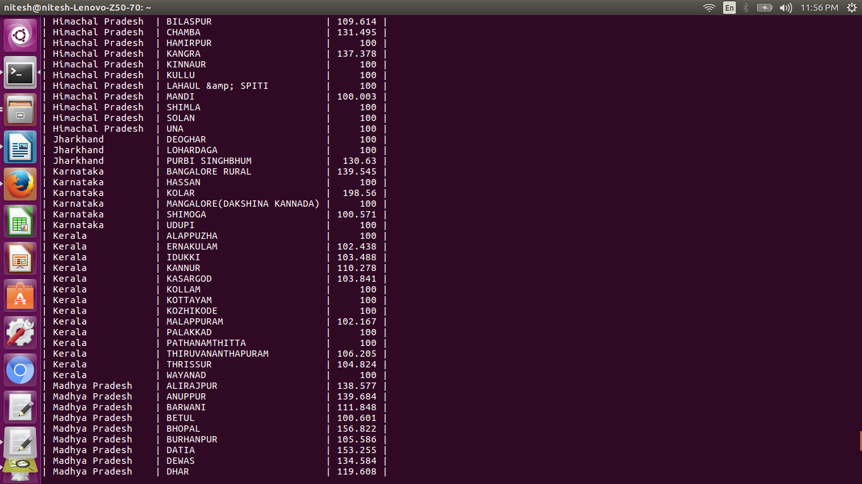

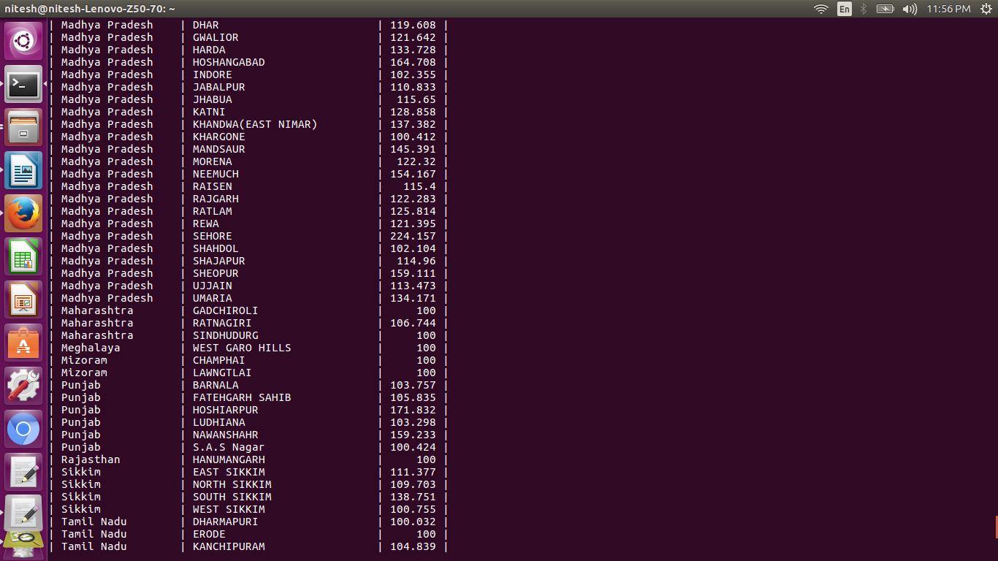

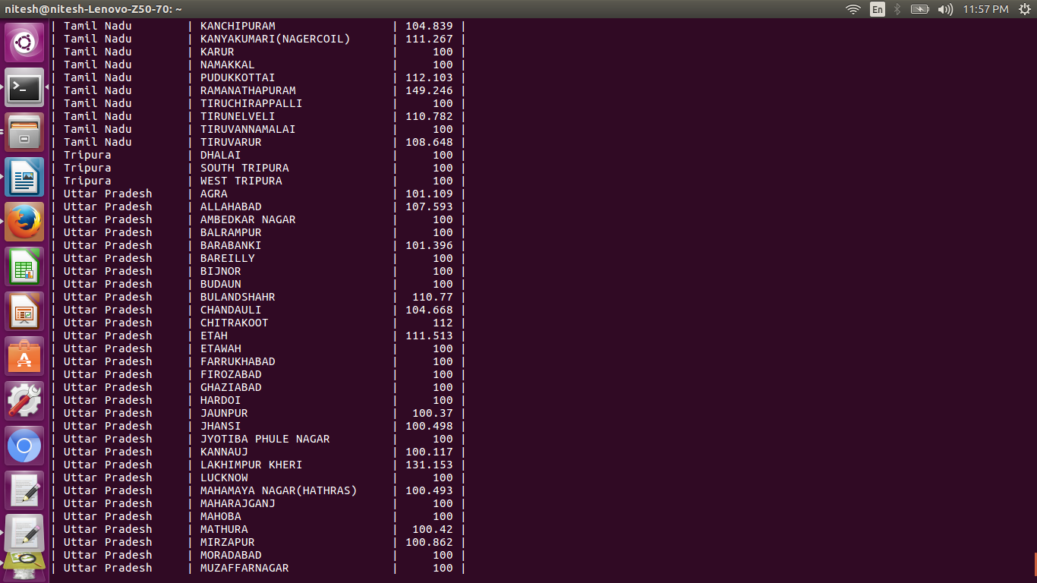

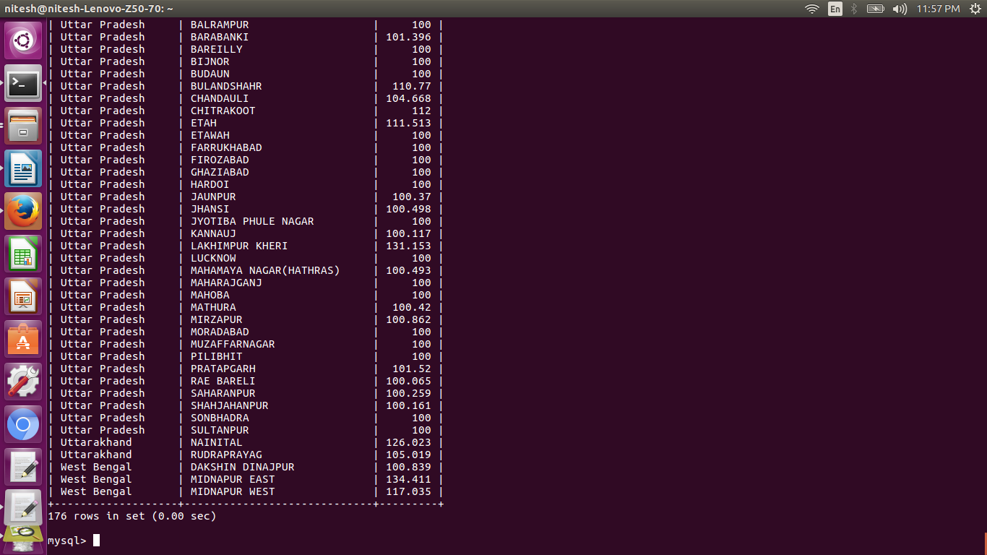

Here when we have executed the code for greater than or equal to 100% we get 176 rows .i.e. the 176 entries having performance greater than or equal to100%

**Problem statement 2**

Write a Pig UDF to filter the districts which have reached 80% of objectives of BPL cards. Export the results to MySQL using Sqoop

*Answer:*

Here we are supposed to write the pig udf to filter the dataset to fetch the data who reached 80% of objectives. So we have written the udfs as shown in the above udf section.

The created udf’s are now registered to use it in the script as shown below using the commands register for both the filter_udf and the percent udf.

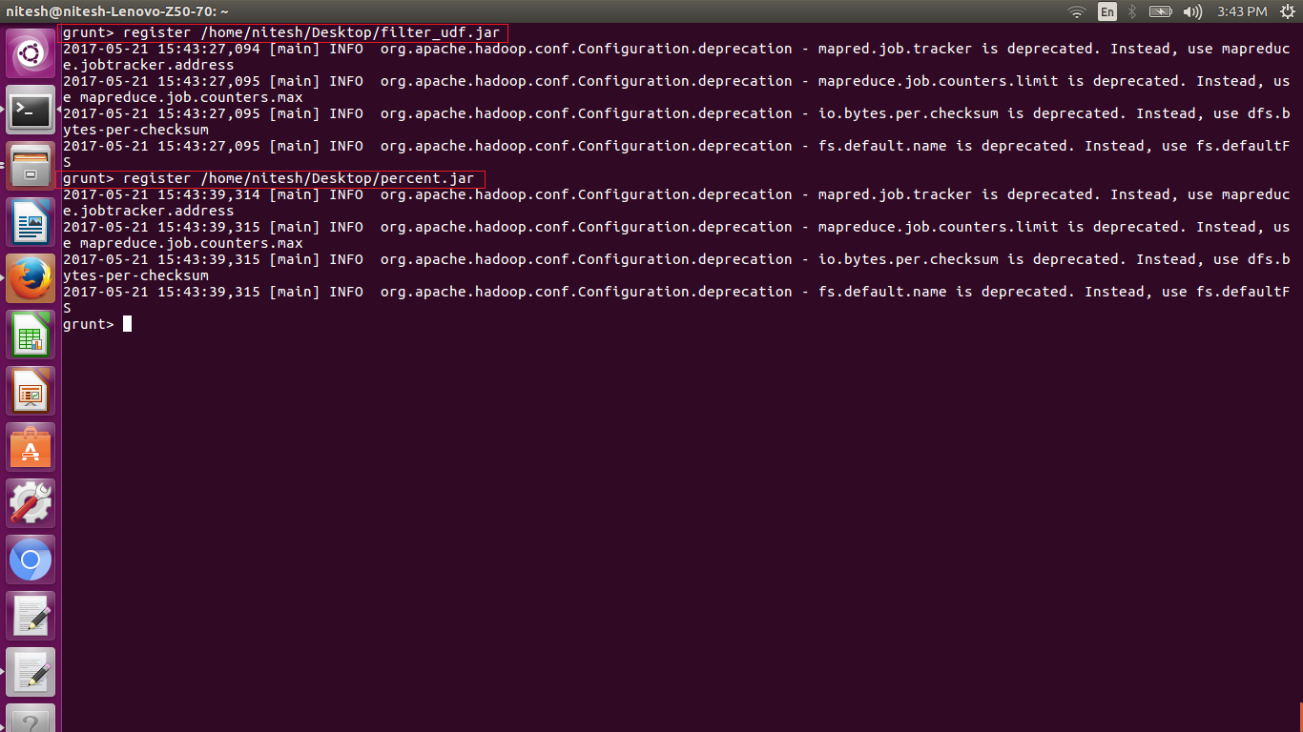

1. Now as we have registered jars we need to load the data set in the variable Input_data.

2. Loading of data is done using the following command

load ‘hdfs:input path’ Using PigStorage(‘delimiter’) as (variable:datatype);

1. After the dataset is loaded in Input_data variable we have applied filter fuction so we can filter the loaded data to fetch the data who has achieved 80% of objective using

filter ‘dataset’ BY condition;

1. Once the filter operation is done we need to generate the columns to be stored using following syntax

foreach ‘filtered data‘ generate state,district,percent;

1. The required columns are generated and now we need to store the data into the hdfs so we use

store ‘generated data’ into ‘path’ using org.apache.pig.piggybank.storage.CSVExelStorage();

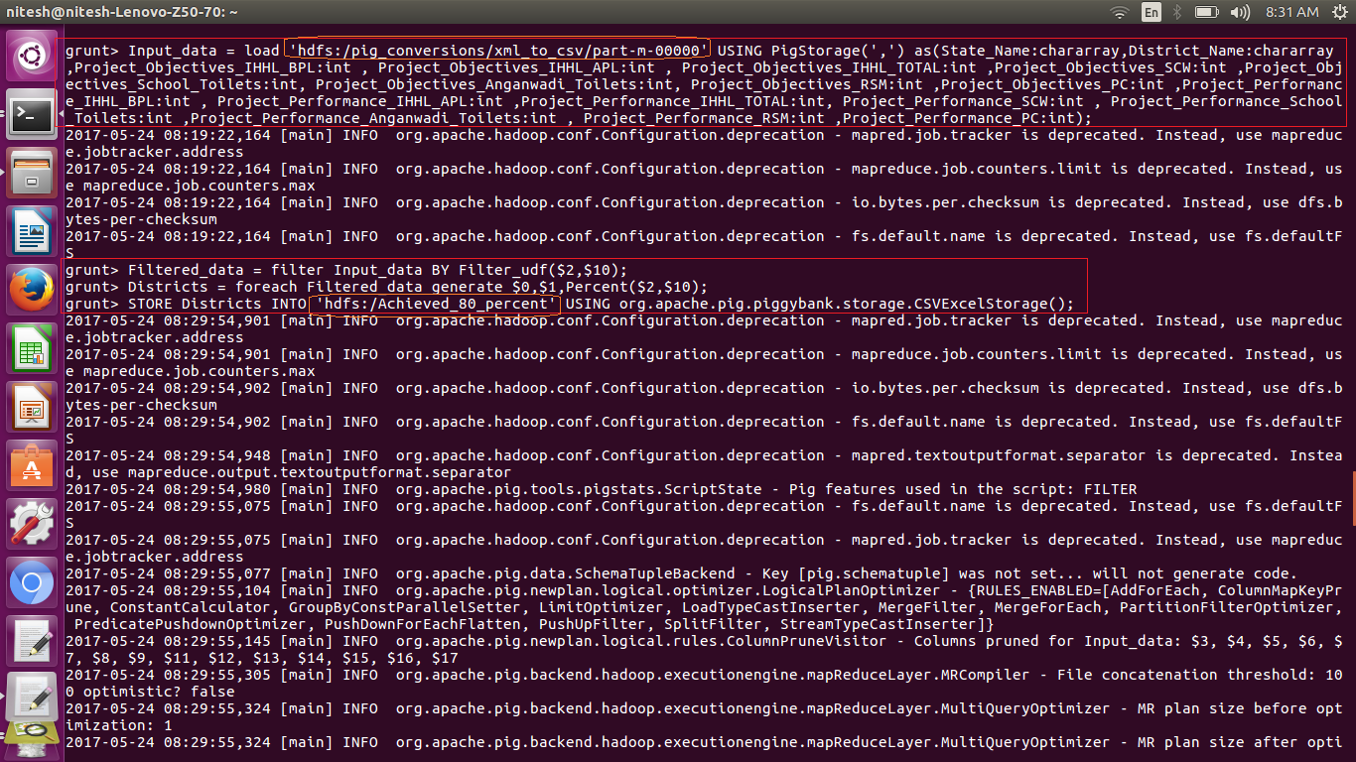

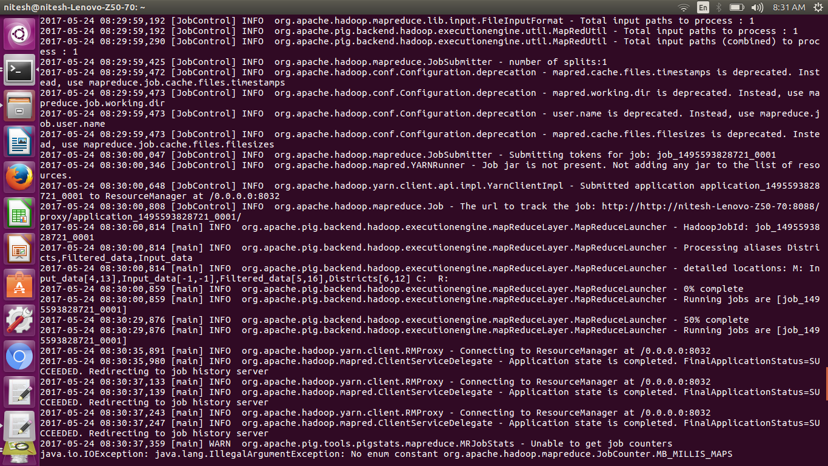

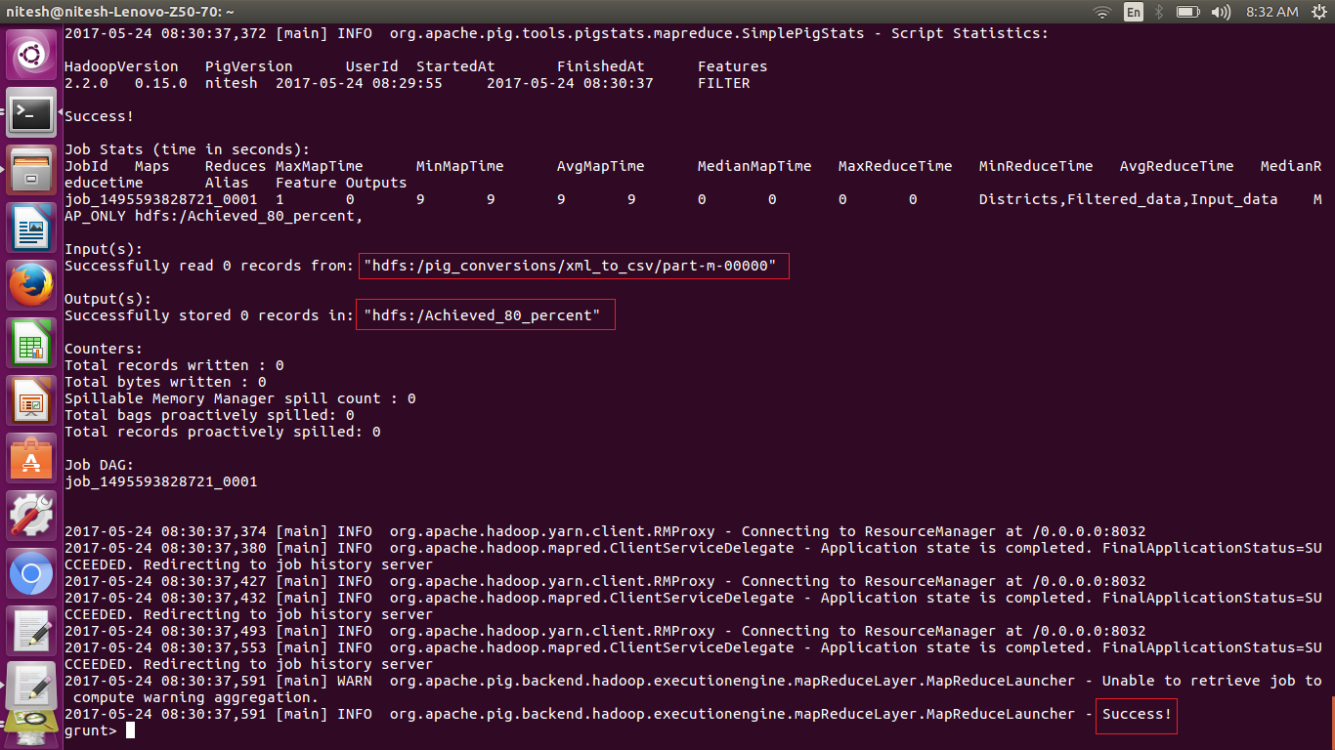

store command was successfully executed and the filtered data is written in the hdfs as we can see in the following image. Where we have used

adoop fs –ls /

to get the folder where we have stored and it is marked with red box in the image

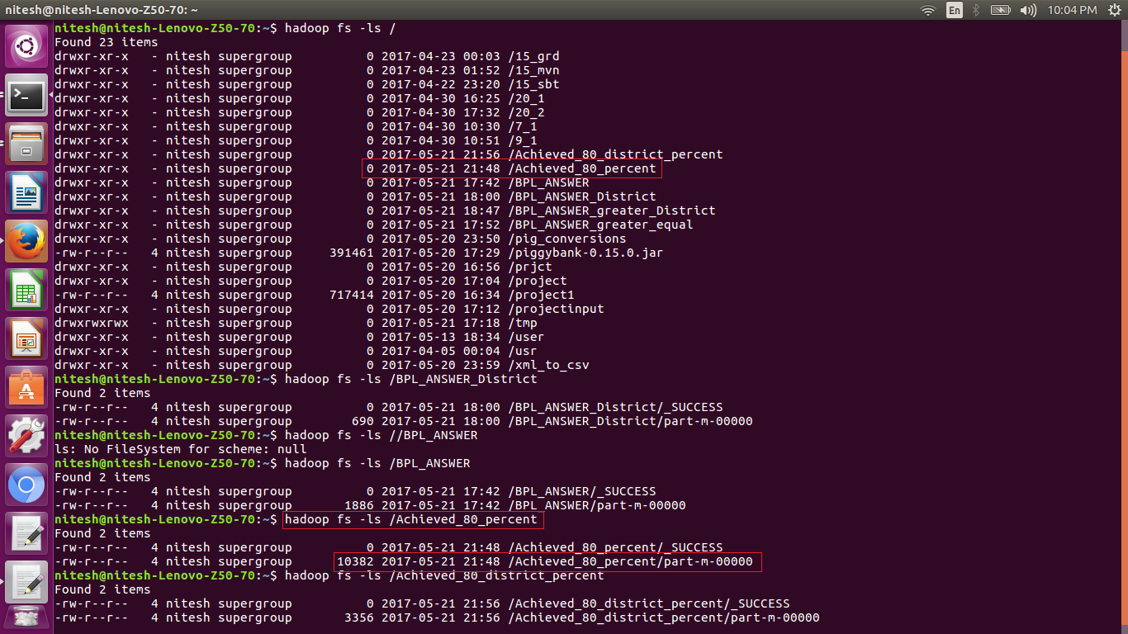

As we now want to export the stored filtered data from hdfs to mysql db we need to create the database to create the table with the required number of columns to export the data from the hdfs to mysql using sqoop as per our requirement.

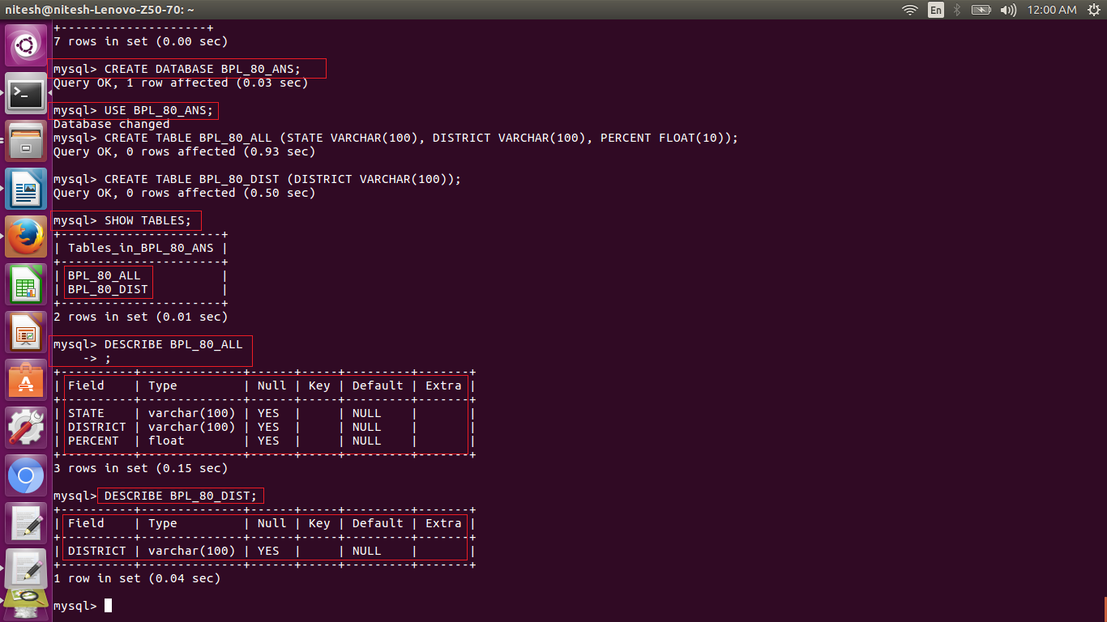

In the below screen shot we can see that the sqoop command is used to export the data from the hdfs to mysql. The command can be used as per below

sqoop export –m 1 – connect jdbc:mysql://localhost:3306/’database name’ –username username –password password –table ‘table name’ –export-dir ‘hdfs path of the file to be exported’ –driver com.mysql.jdbc.Driver

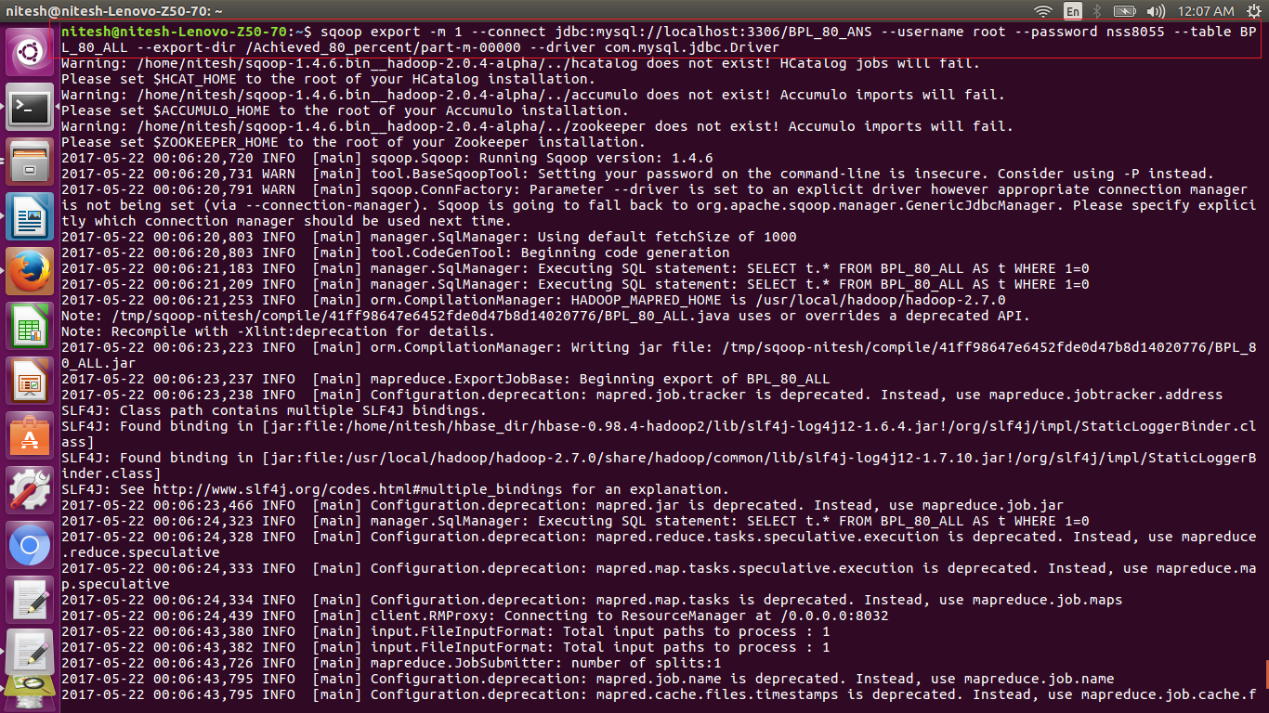

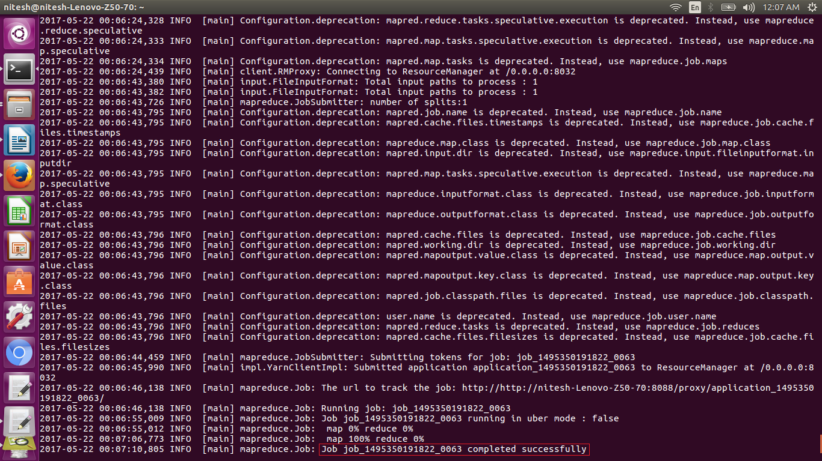

Here in the above image we can see in the red box that the job is completed successfully. So the data is being exported to mysql database.

To verify we open the mysql using the command

mysql –u root –p

After the mysql shell is open we need to use the created database using the command use ‘database name’

then use use the table to query the data in the table using the select query as

select * from ‘table name’;

and we fetch all the data from the table that is exported using sqoop from hdfs.

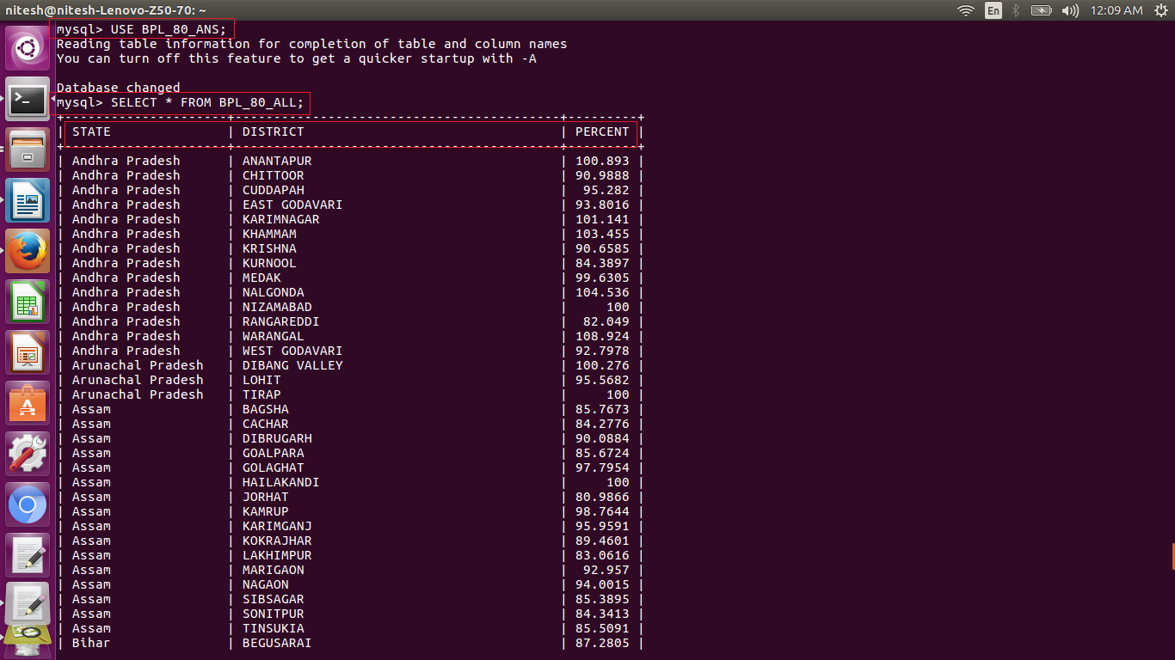

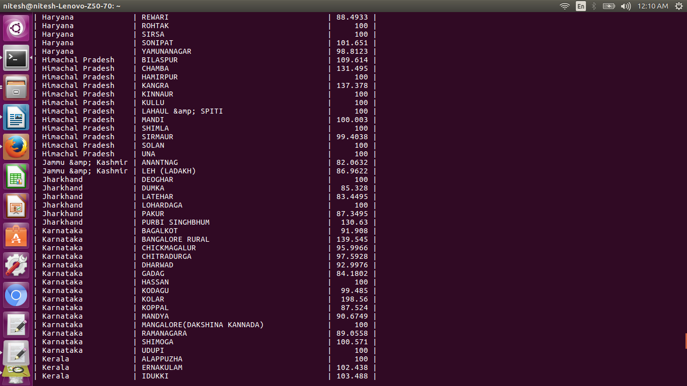

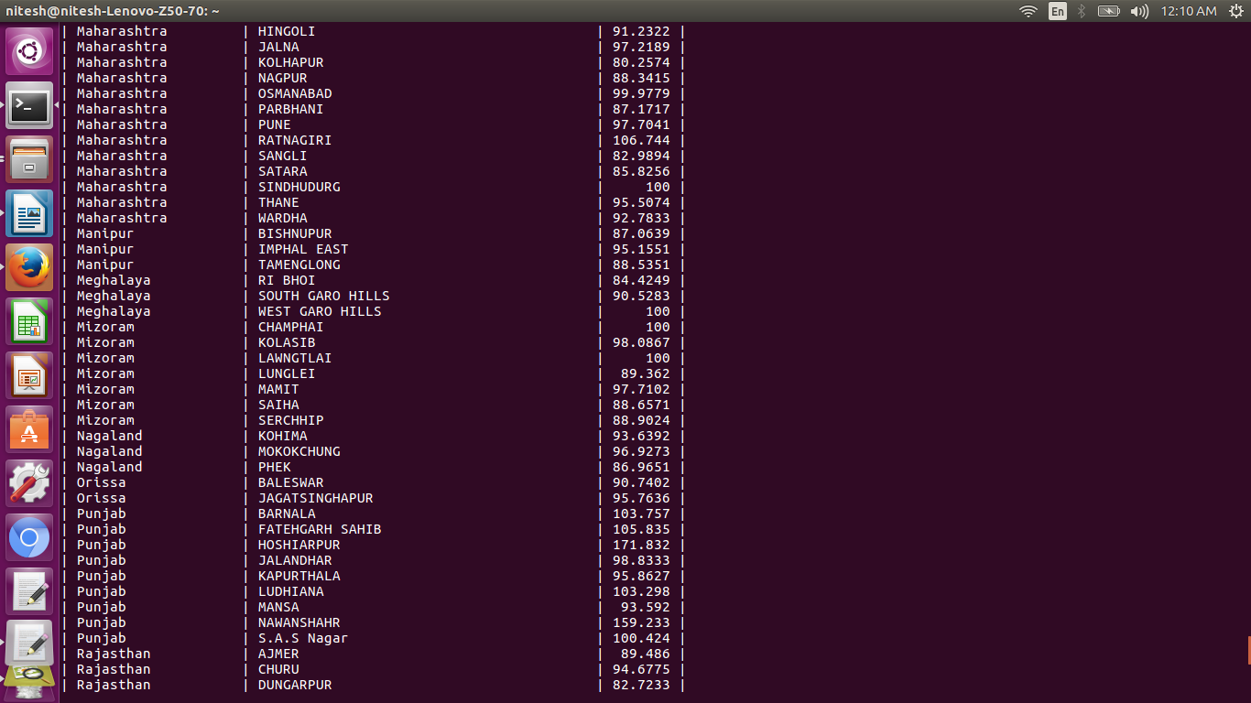

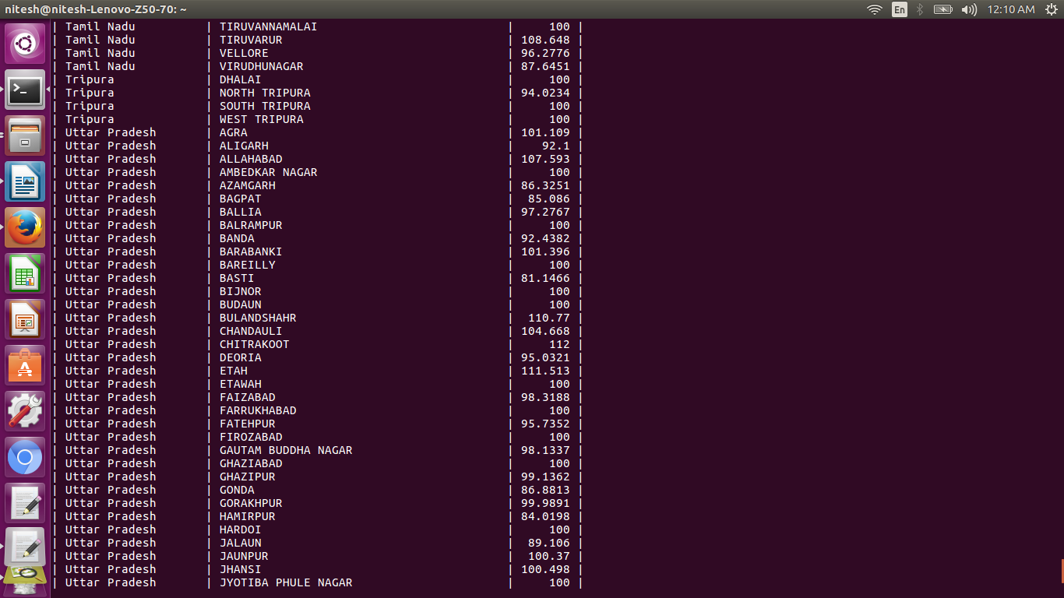

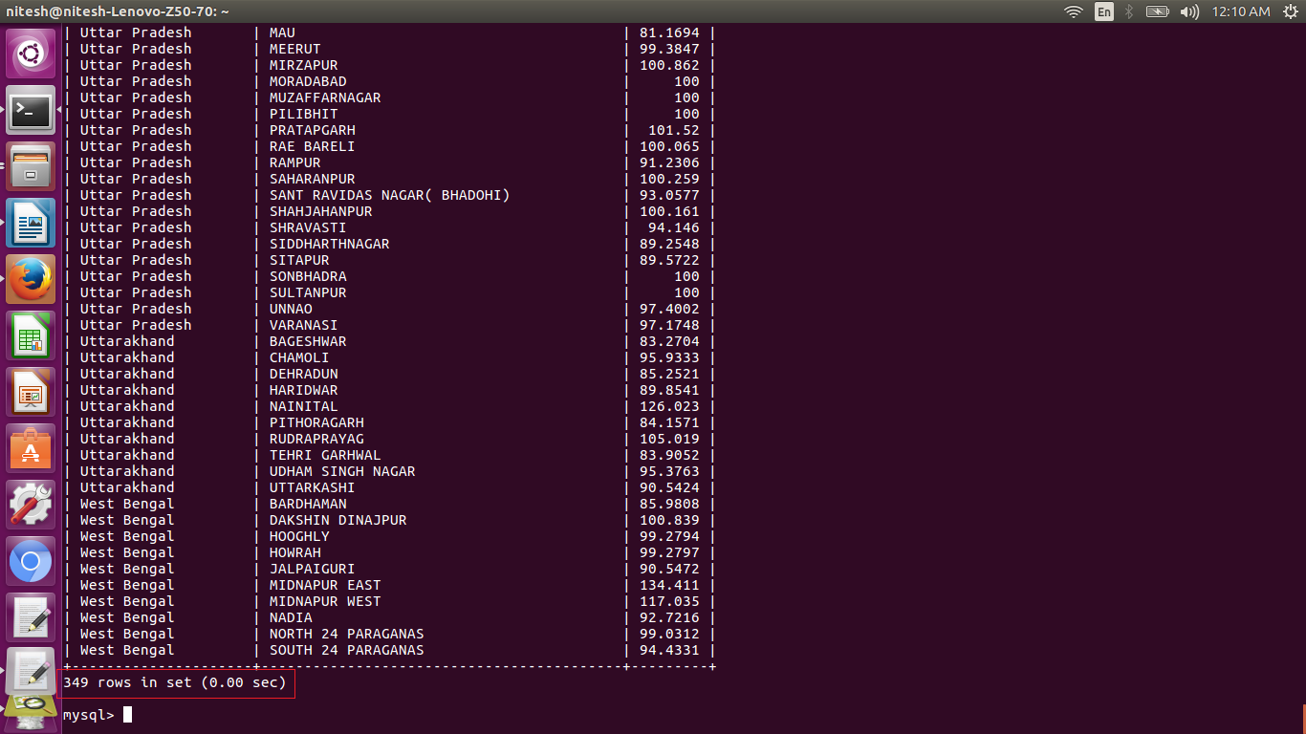

here we have 349 rows in the table that is the number of entries who achieved 80% of the objective

*Here we have screen shots of the processes we followed as of above fo the condition greater than or equal to 80% using pig udf to generate all districts only.*

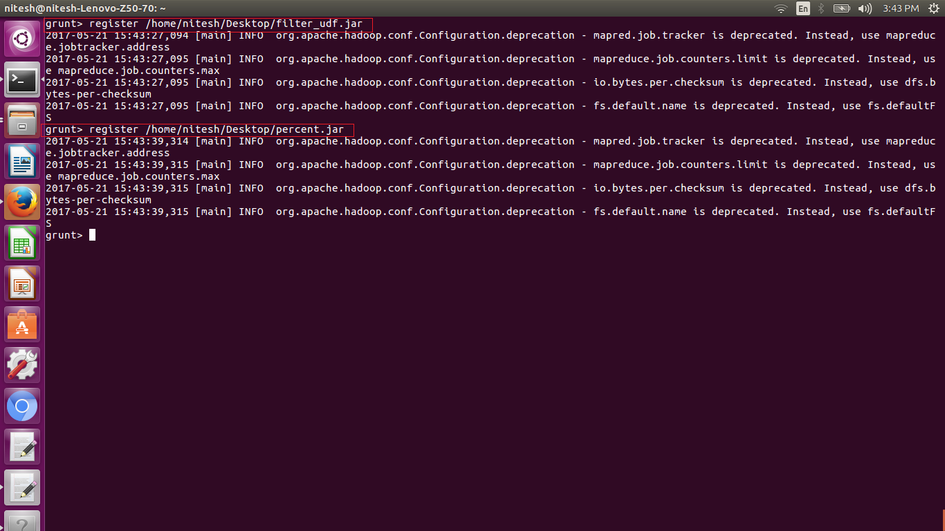

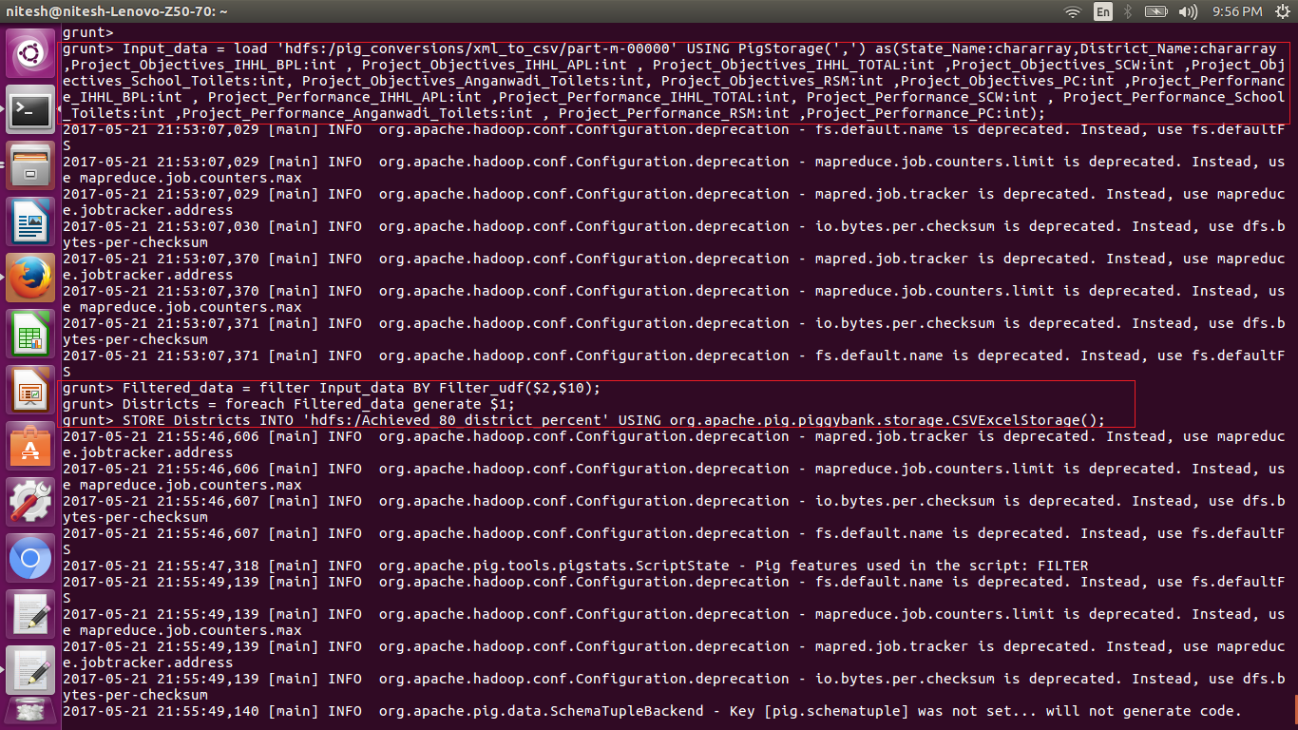

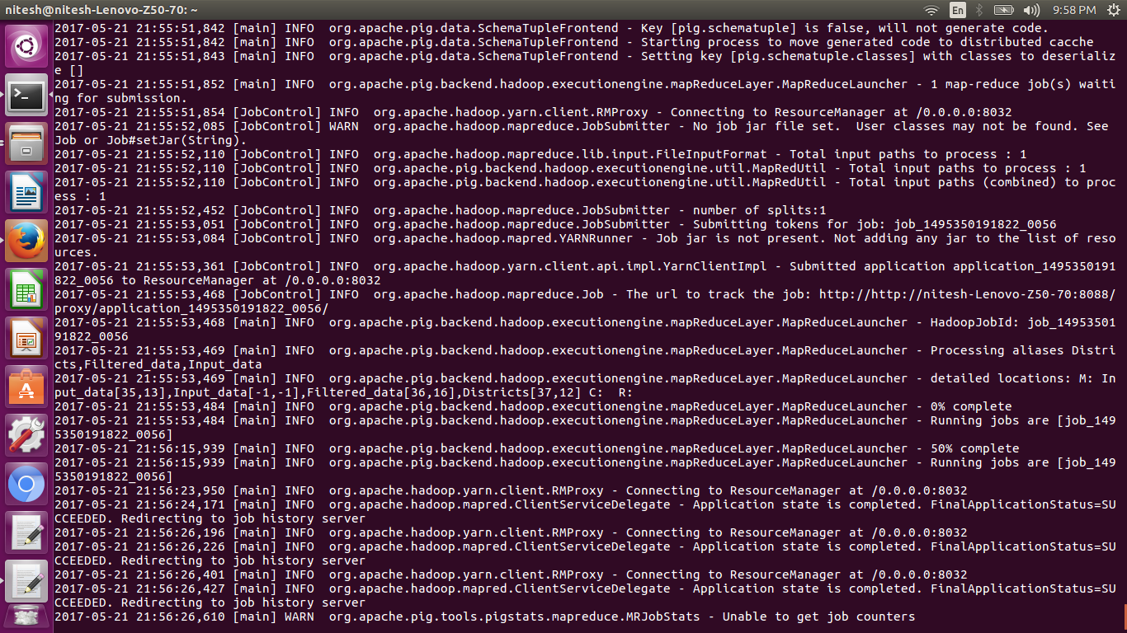

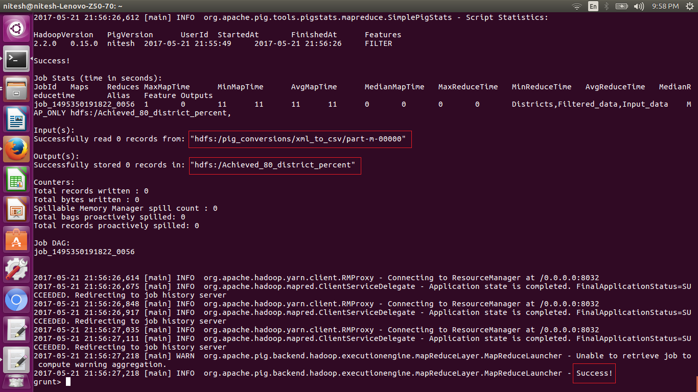

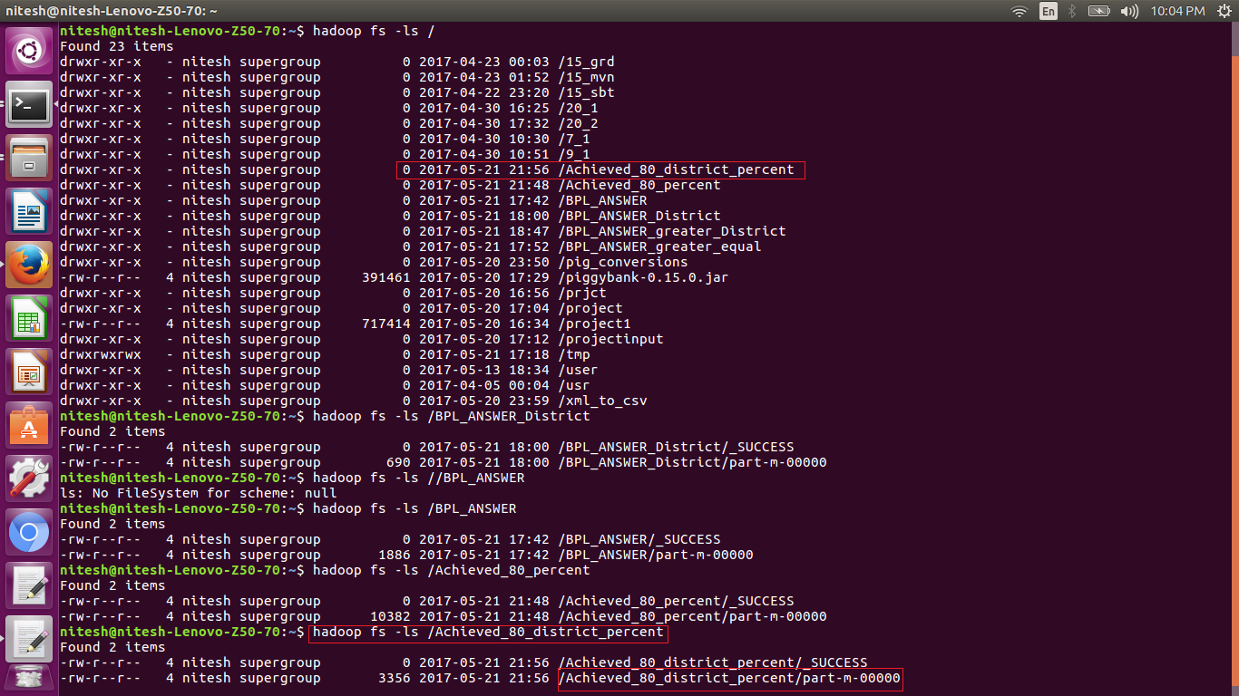

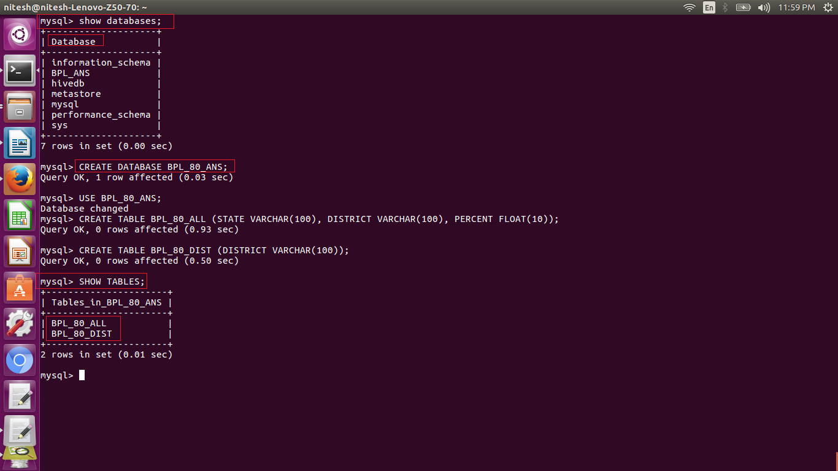



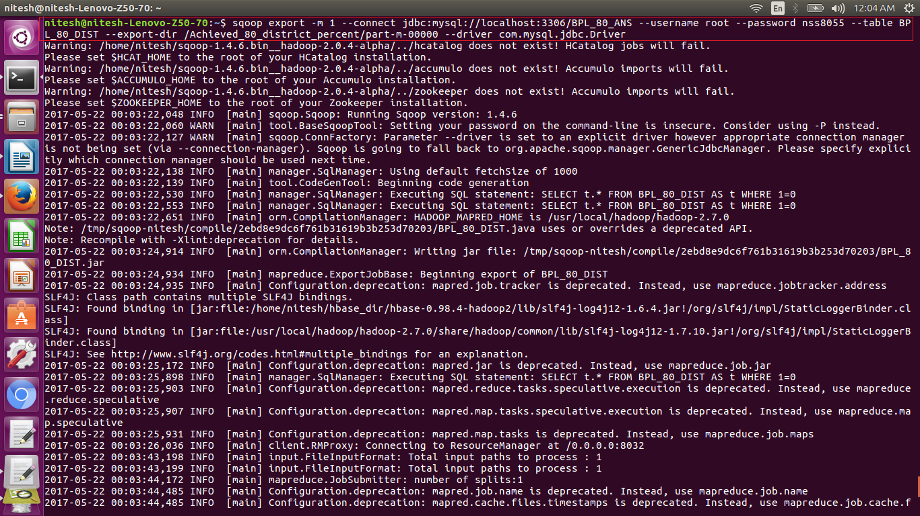

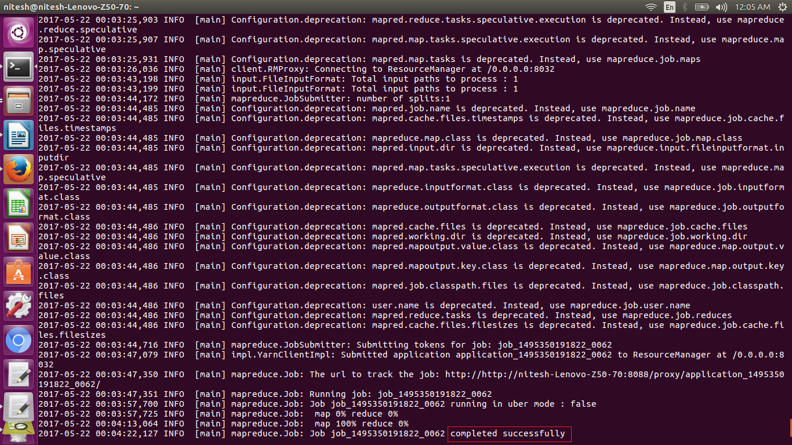

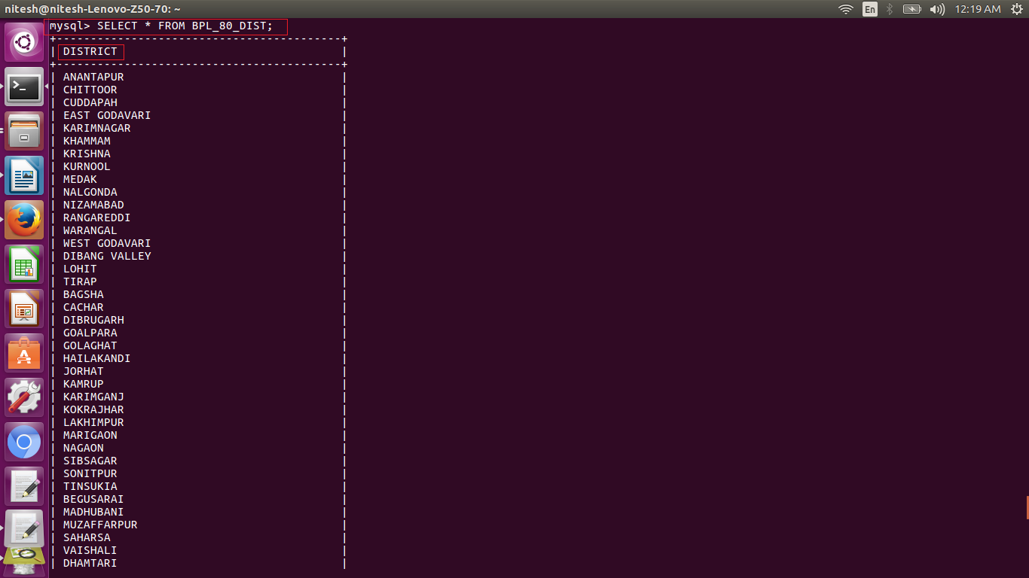

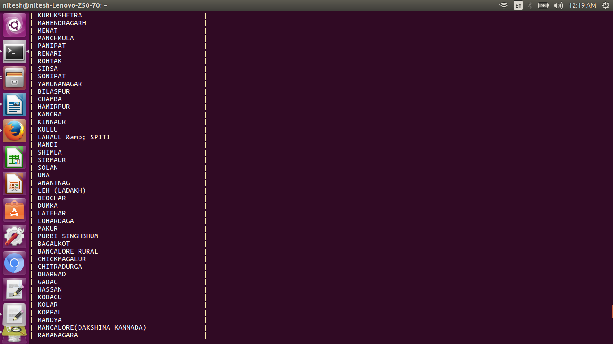

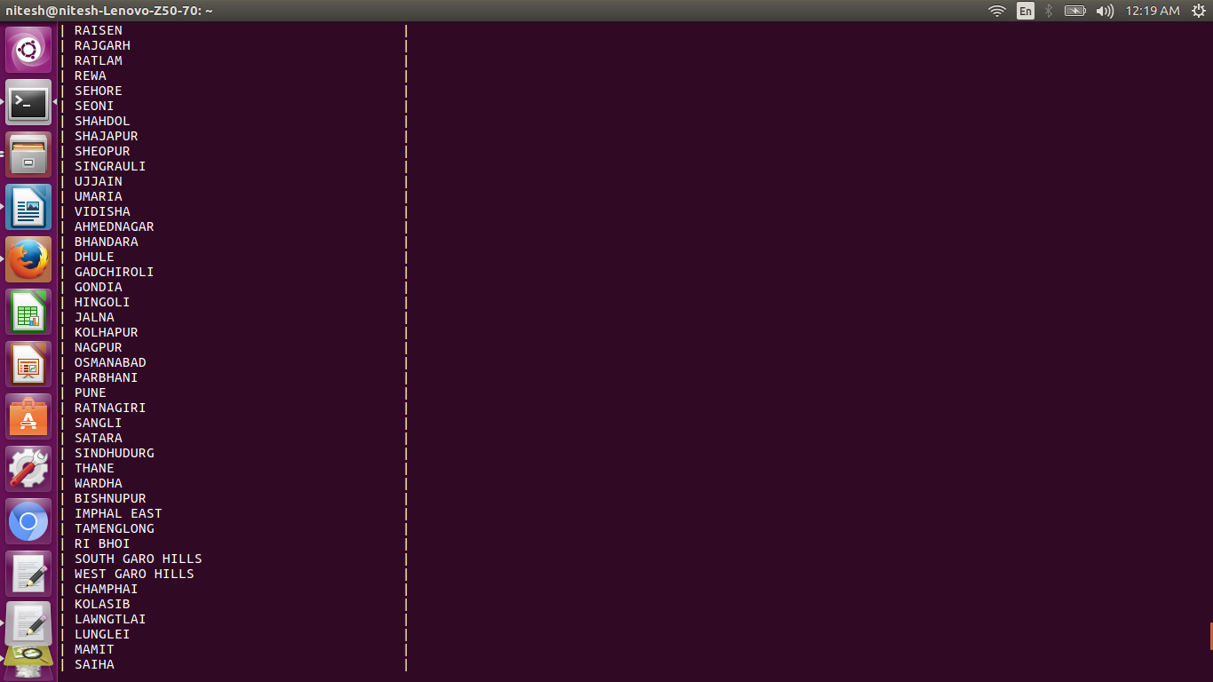

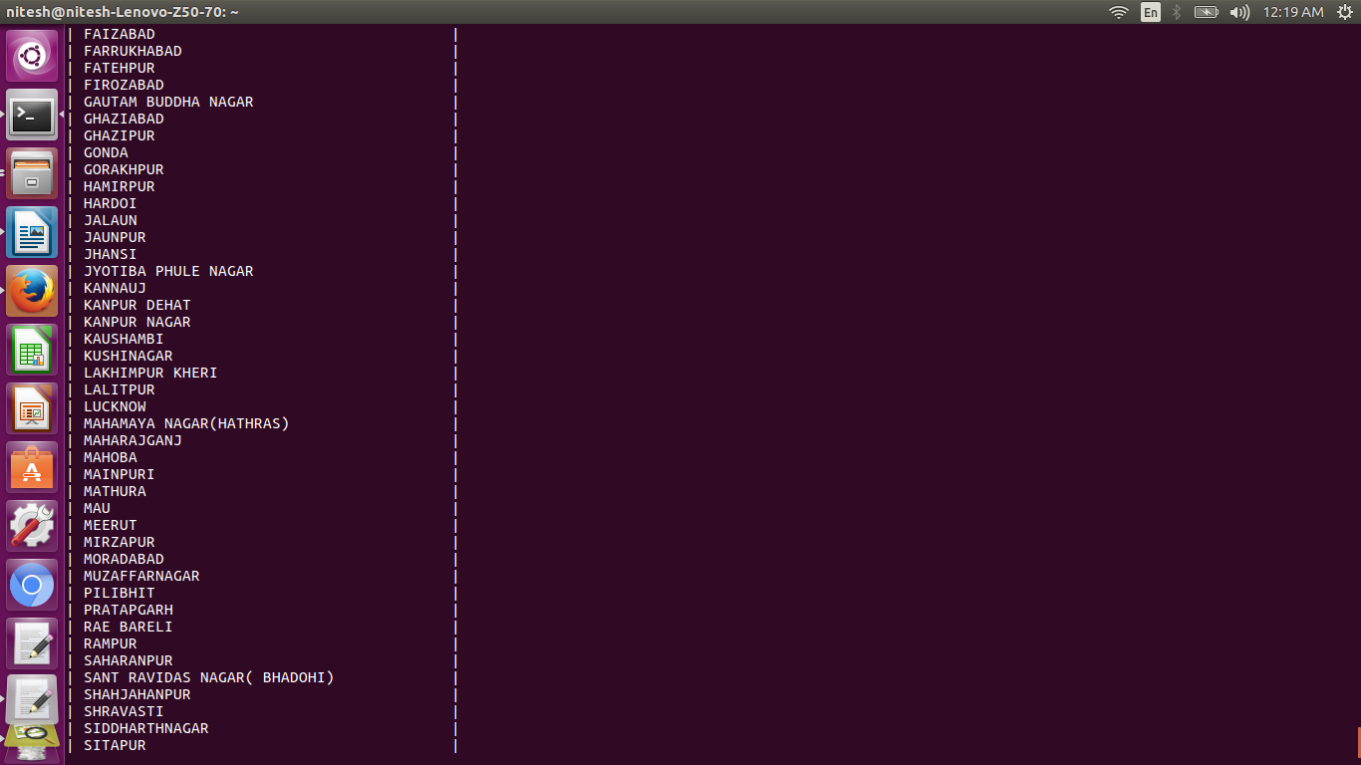

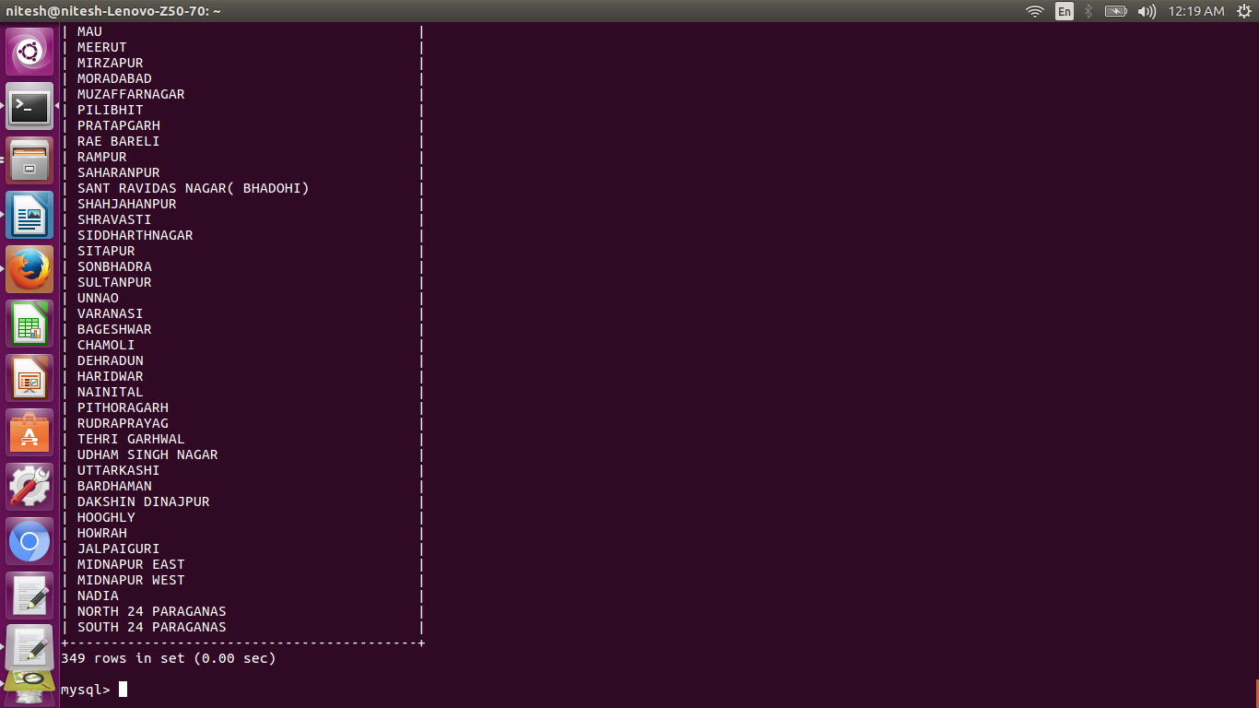

Shell Scripting

What is "the shell"?

Simply put, the shell is a program that takes your commands from the keyboard and gives them to the operating system to perform. In the old days, it was the only user interface available on a Unix computer. Nowadays, we have graphical user interfaces (GUIs) in addition to command line interfaces (CLIs) such as the shell.

On most Linux systems a program called bash (which stands for Bourne Again SHell, an enhanced version of the original Bourne shell program, sh, written by Steve Bourne) acts as the shell program. There are several additional shell programs available on a typical Linux system. These include: ksh, tcsh and zsh.

How to write shell script?

Following steps are required to write shell script:

(1) Use any editor like vi or mcedit to write shell script.

(2) After writing shell script set execute permission for your script as follows  
*syntax:*  
chmod permission your-script-name

*Examples:*  
$ chmod +x your-script-name  
$ chmod 755 your-script-name

This will set read write execute(7) permission for owner, for group and other permission is read and execute only(5).

(3) Execute your script as  
*syntax:*  
bash your-script-name  
sh your-script-name  
./your-script-name

Here we have written the shell script for both the questions in the single script

The flow of the script is as follows:

* First we have started all the daemons
* Secondly we have deleted the directories if they are available and created it again so the previous data is cleared or deleted.
* Then the timeout function is used to kill the flume command to stop it after 30s of exection.
* Then the pig script is used to convert the xml_to_csv. This script is stored in the file with extension .pig
* The pig scripts are passed as pig ‘script _name’
* Then we used mysql to create the table, for that we used the syntax

Mysql –u root –ppassword <<EOF

Commands

EOF

This will execute the commands in the mysql. The <<EOF tells that it should execute the commands in EOF till EOF appears again.

* Then we used the sqoop command to export the generated output from hdfs to mysql
* Lastly we displayed the exported result by querying the tables.

1. ***The pig script to convert the xml_to_csv is as follows:***

A = load 'hdfs:/shell/project/StatewiseDistrictwisePhysicalProgress.xml' using org.apache.pig.piggybank.storage.XMLLoader('row') as (x:chararray);

B = foreach A generate REPLACE(x,'[\\n]','') as x;

C = foreach B generate REGEX_EXTRACT_ALL(x,'.*(?:<State_Name>)([^<]*).*(?:<District_Name>)([^<]*).*(?:<Project_Objectives_IHHL_BPL>)([^<]*).*(?:<Project_Objectives_IHHL_APL>)([^<]*).*(?:<Project_Objectives_IHHL_TOTAL>)([^<]*).*(?:<Project_Objectives_SCW>)([^<]*).*(?:<Project_Objectives_School_Toilets>)([^<]*).*(?:<Project_Objectives_Anganwadi_Toilets>)([^<]*).*(?:<Project_Objectives_RSM>)([^<]*).*(?:<Project_Objectives_PC>)([^<]*).*(?:<Project_Performance-IHHL_BPL>)([^<]*).*(?:<Project_Performance-IHHL_APL>)([^<]*).*(?:<Project_Performance-IHHL_TOTAL>)([^<]*).*(?:<Project_Performance-SCW>)([^<]*).*(?:<Project_Performance-School_Toilets>)([^<]*).*(?:<Project_Performance-Anganwadi_Toilets>)([^<]*).*(?:<Project_Performance-RSM>)([^<]*).*(?:<Project_Performance-PC>)([^<]*).*');

D =FOREACH C GENERATE FLATTEN (($0));

STORE D INTO 'hdfs://localhost:9000/shell/pig_conversions/xml_to_csv' USING org.apache.pig.piggybank.storage.CSVExcelStorage();

1. ***The pig script for question 1 is as follows:***

register /home/nitesh/Desktop/filter_udf.jar

register /home/nitesh/Desktop/percent.jar

Input_data = load 'hdfs:/shell/pig_conversions/xml_to_csv/part-m-00000' USING PigStorage(',') as(State_Name:chararray,District_Name:chararray ,Project_Objectives_IHHL_BPL:int , Project_Objectives_IHHL_APL:int , Project_Objectives_IHHL_TOTAL:int ,Project_Objectives_SCW:int ,Project_Objectives_School_Toilets:int, Project_Objectives_Anganwadi_Toilets:int, Project_Objectives_RSM:int ,Project_Objectives_PC:int ,Project_Performance_IHHL_BPL:int , Project_Performance_IHHL_APL:int ,Project_Performance_IHHL_TOTAL:int, Project_Performance_SCW:int , Project_Performance_School_Toilets:int ,Project_Performance_Anganwadi_Toilets:int , Project_Performance_RSM:int ,Project_Performance_PC:int);

Filtered_data = filter Input_data BY $2==$10;

Districts = foreach Filtered_data generate $0,$1,Percent($2,$10);

STORE Districts INTO 'hdfs:/shell/BPL_ANSWER' USING org.apache.pig.piggybank.storage.CSVExcelStorage();

The flow and explanation of commands is same as the Problem statement 1

1. ***The pig script for question 2 is as follows:***

register /home/nitesh/Desktop/filter_udf.jar

register /home/nitesh/Desktop/percent.jar

Input_data = load 'hdfs:/shell/pig_conversions/xml_to_csv/part-m-00000' USING PigStorage(',') as(State_Name:chararray,District_Name:chararray ,Project_Objectives_IHHL_BPL:int , Project_Objectives_IHHL_APL:int , Project_Objectives_IHHL_TOTAL:int ,Project_Objectives_SCW:int ,Project_Objectives_School_Toilets:int, Project_Objectives_Anganwadi_Toilets:int, Project_Objectives_RSM:int ,Project_Objectives_PC:int ,Project_Performance_IHHL_BPL:int , Project_Performance_IHHL_APL:int ,Project_Performance_IHHL_TOTAL:int, Project_Performance_SCW:int , Project_Performance_School_Toilets:int ,Project_Performance_Anganwadi_Toilets:int , Project_Performance_RSM:int ,Project_Performance_PC:int);

Filtered_data = filter Input_data BY Filter_udf($2,$10);

Districts = foreach Filtered_data generate $0,$1,Percent($2,$10);

STORE Districts INTO 'hdfs:/shell/BPL_ANSWER_80' USING org.apache.pig.piggybank.storage.CSVExcelStorage();

1. ***The shell script for major project is as follows:***

***###############################################################***

#!/bin/bash

start-all.sh

hadoop fs -rm -r -skipTrash /shell

#hadoop fs -rm -r -skipTrash /shell/project

hadoop fs -mkdir /shell

hadoop fs -mkdir /shell/pig_conversions/xml_to_csv/

hadoop fs -mkdir /shell/project/

timeout 30s flume-ng agent -n agent1 -c conf -f /home/nitesh/apache-flume-1.6.0-bin/conf/filecopy.conf

mr-jobhistory-daemon.sh start historyserver

pig xml_to_csv.pig

pig que1.pig

pig que2.pig

mysql -u root -pnss8055 <<EOF

use shell;

DROP TABLE IF EXISTS shell_que1;

CREATE TABLE shell_que1 (state VARCHAR(100),district VARCHAR(100),percent FLOAT(10));

DROP TABLE IF EXISTS shell_que2;

CREATE TABLE shell_que2 (state VARCHAR(100),district VARCHAR(100),percent FLOAT(10));

EOF

sqoop export -m 1 --connect jdbc:mysql://localhost:3306/shell --username root --password nss8055 --table shell_que1 --export-dir /shell/BPL_ANSWER --driver com.mysql.jdbc.Driver

sqoop export -m 1 --connect jdbc:mysql://localhost:3306/shell --username root --password nss8055 --table shell_que2 --export-dir /shell/BPL_ANSWER_80 --driver com.mysql.jdbc.Driver

mysql -u root -pnss8055 <<EOF

#here the shell database is already created

use shell;

SELECT * FROM shell_que1;

EOF

echo "OUTPUT OF THE SECOND SCRIPT"

mysql -u root -pnss8055 <<EOF

use shell;

SELECT * FROM shell_que2;

EOF

########################################################

The above script is stored as project2.sh, the extension .sh is not important but we use in general practice.

Below are the screen shots of the execution of the shell script

The command we used for the execution is

./project.sh(shell script name)

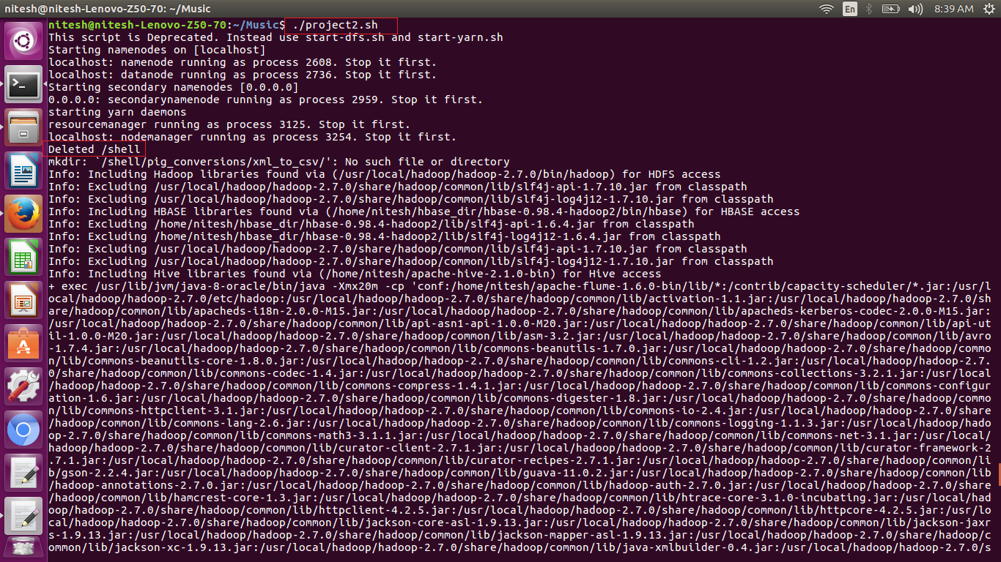

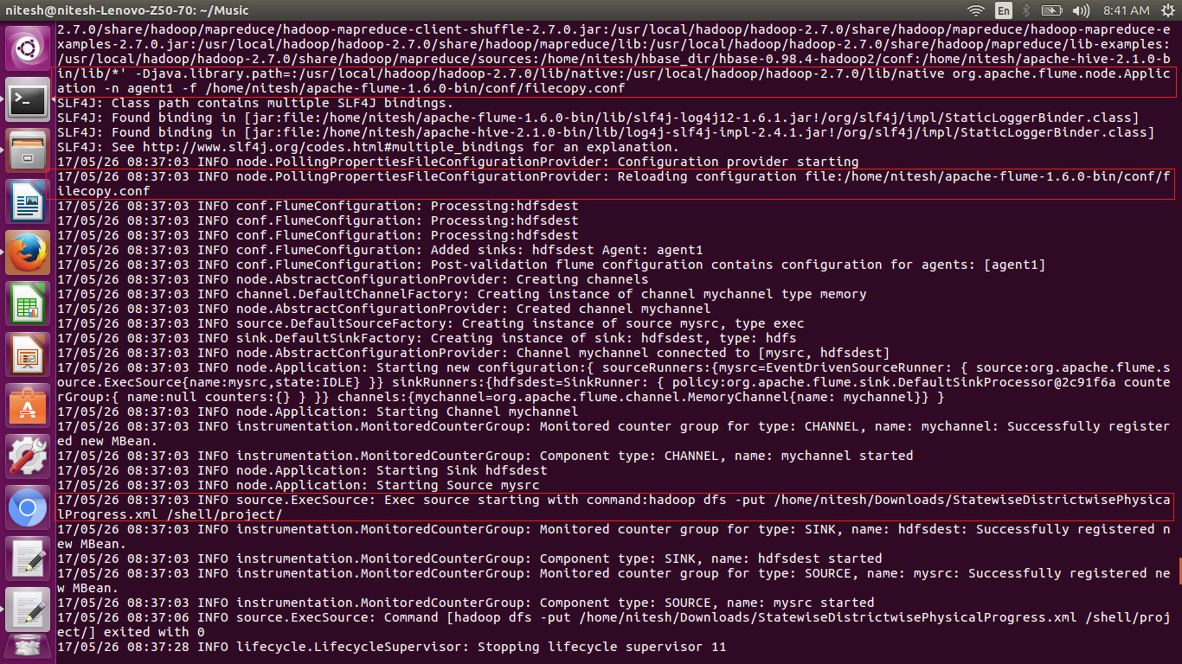

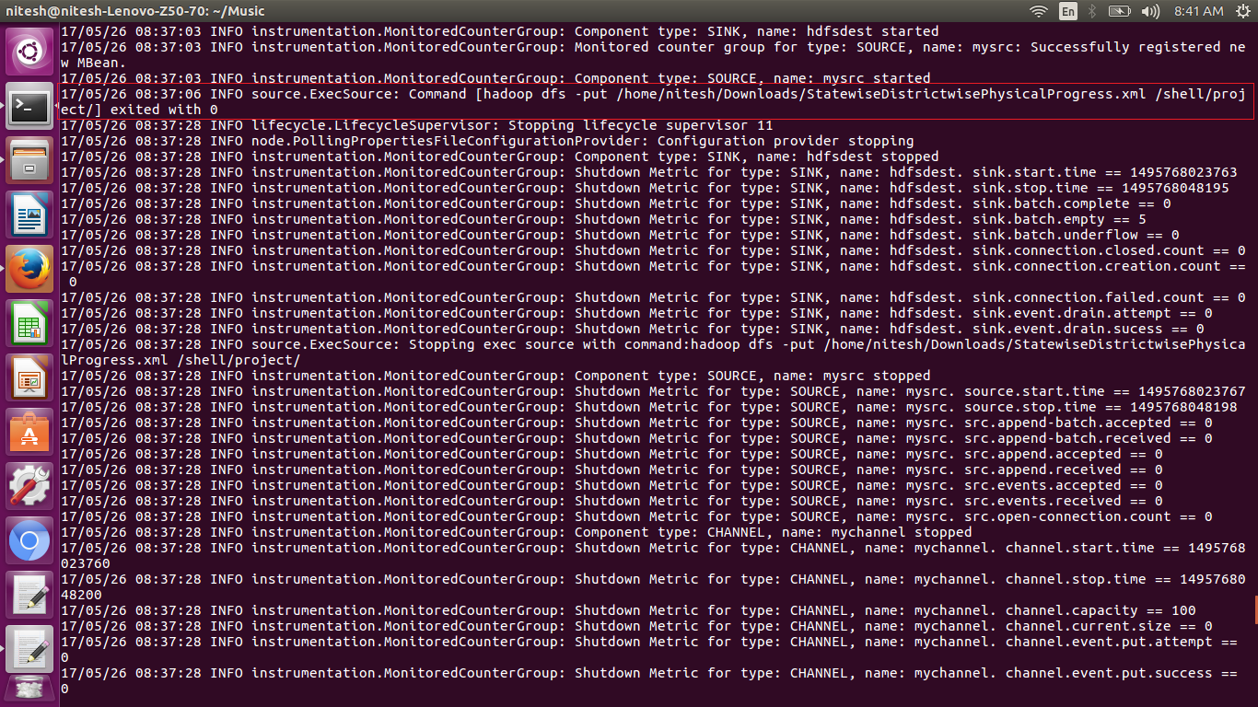

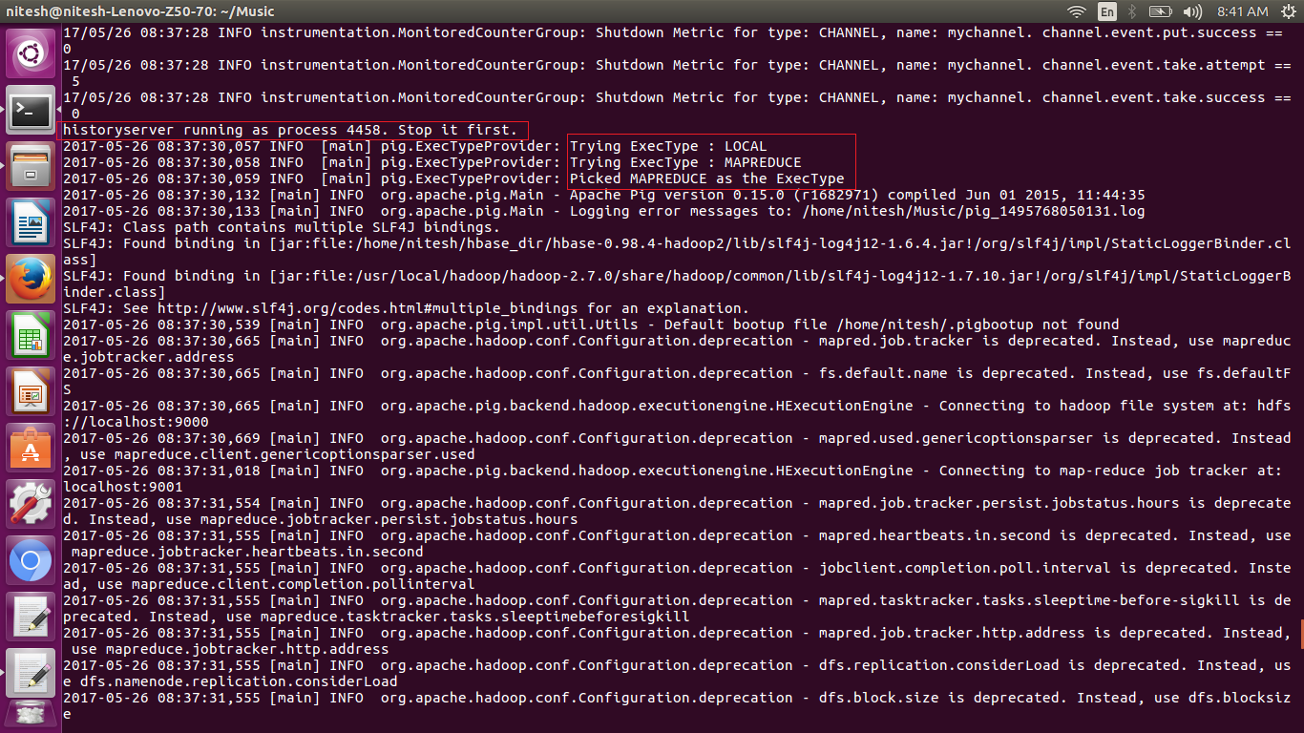

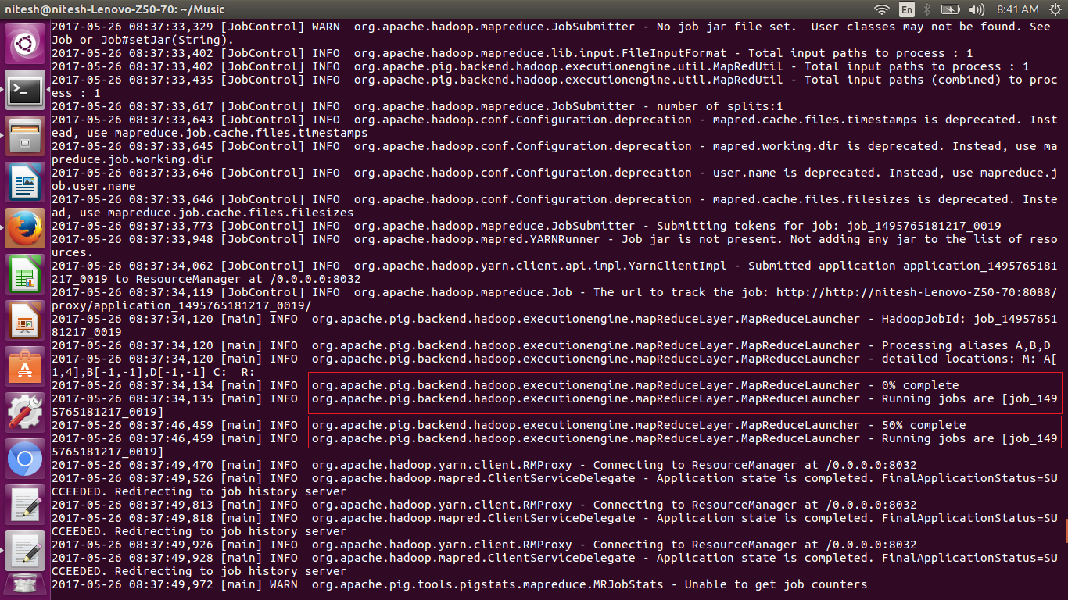

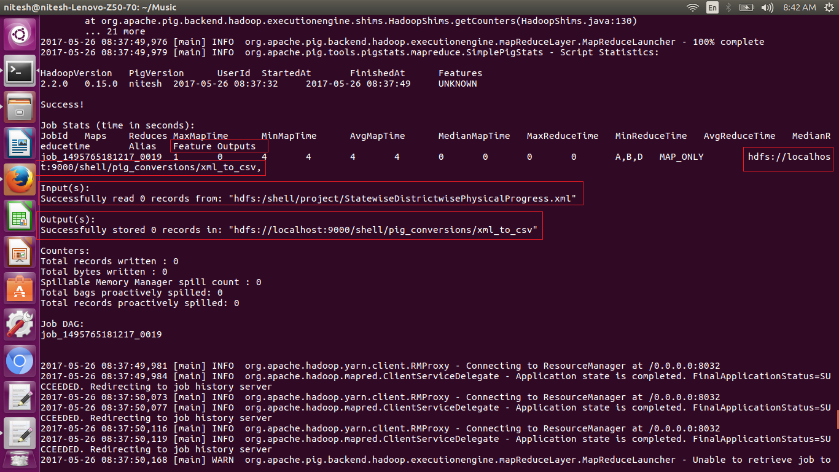

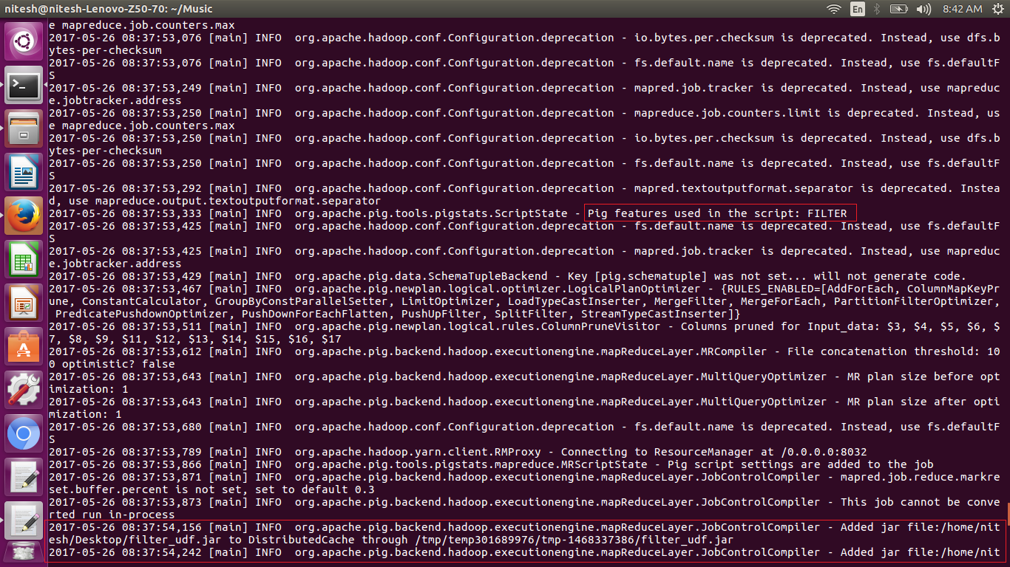

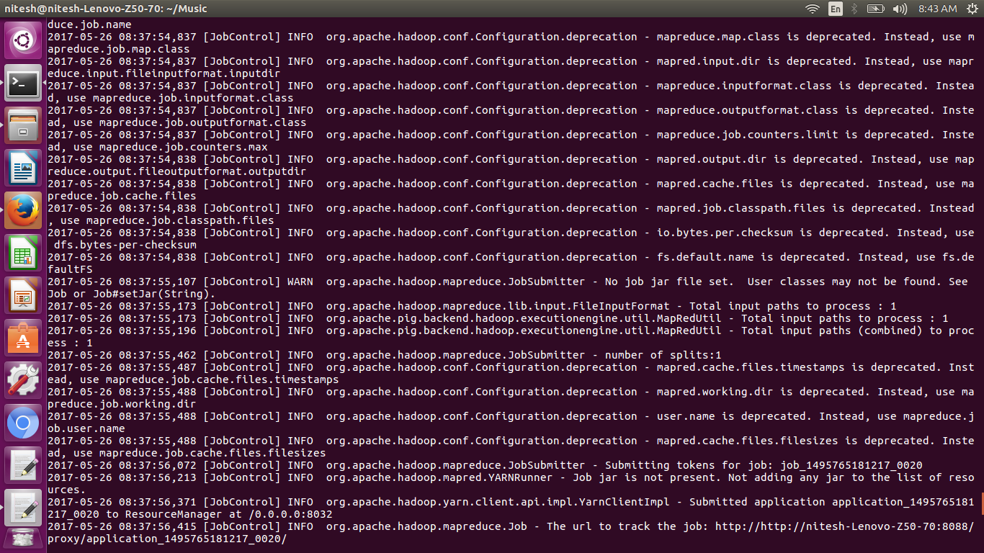

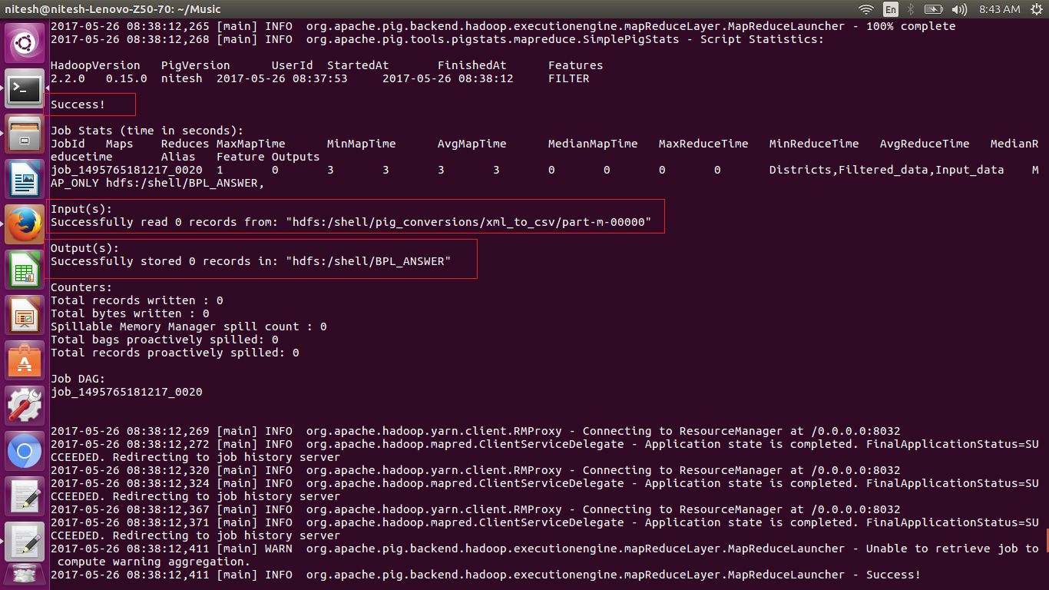

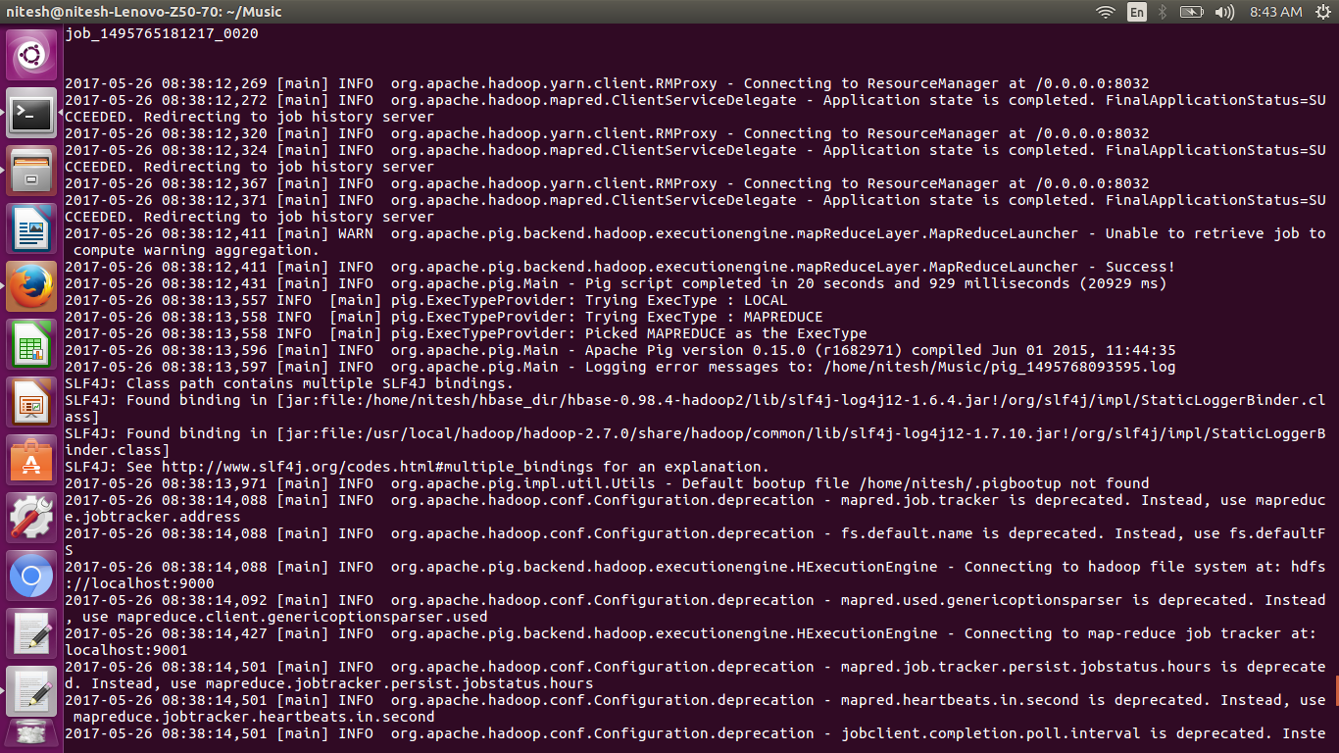

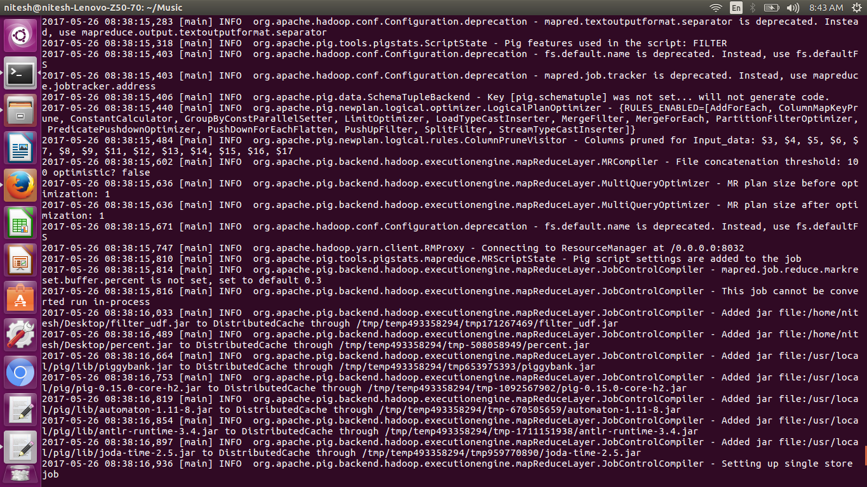

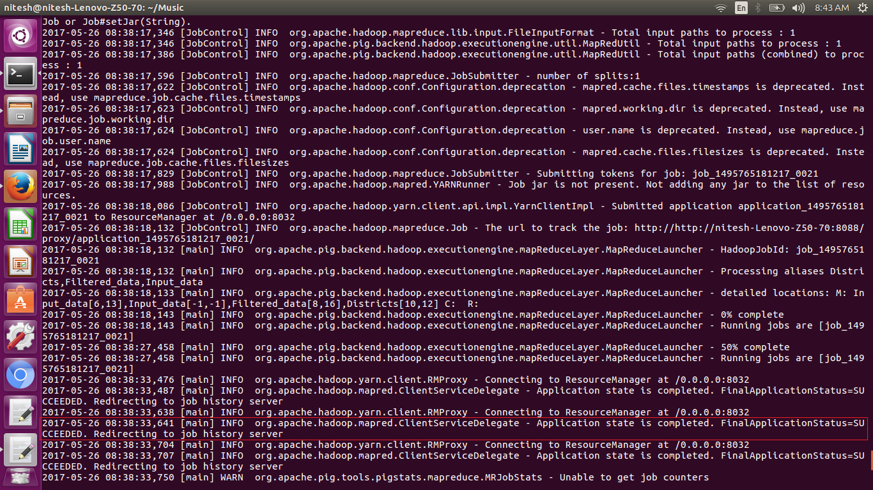

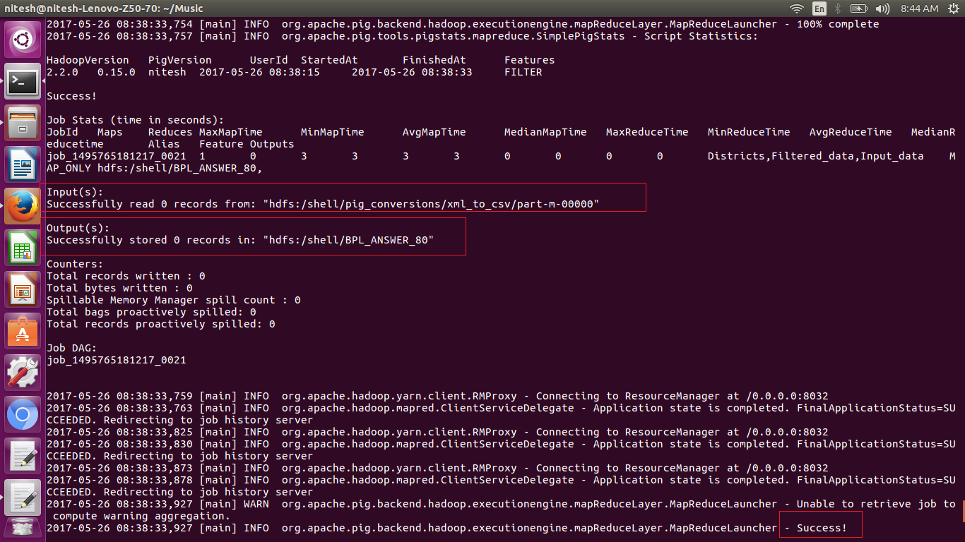

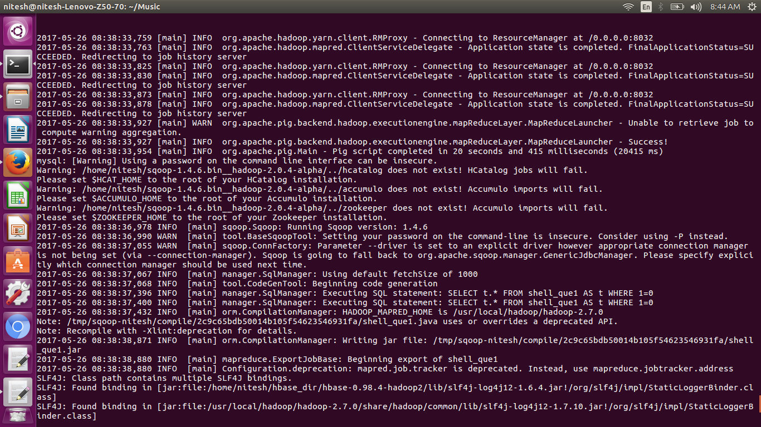

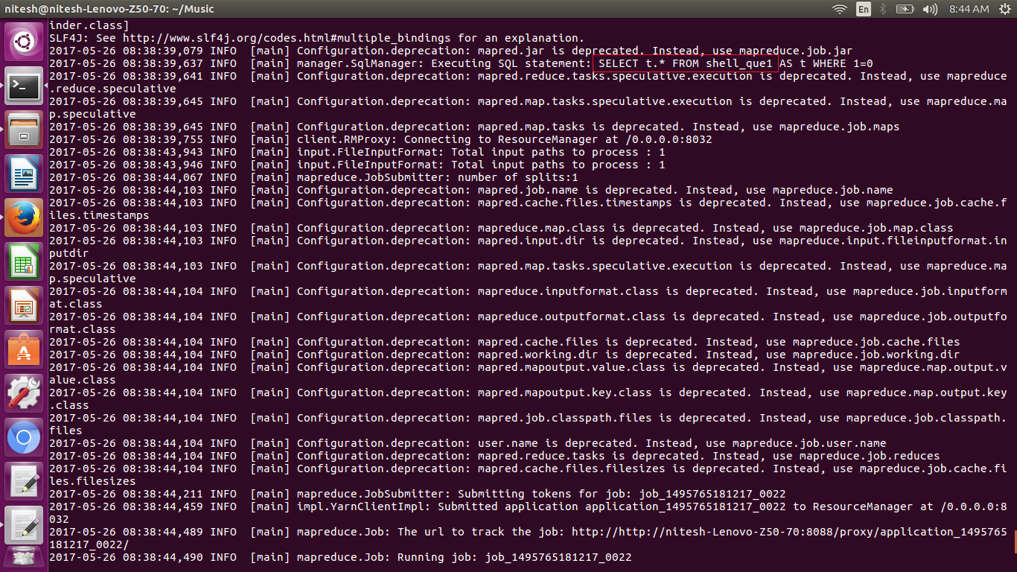

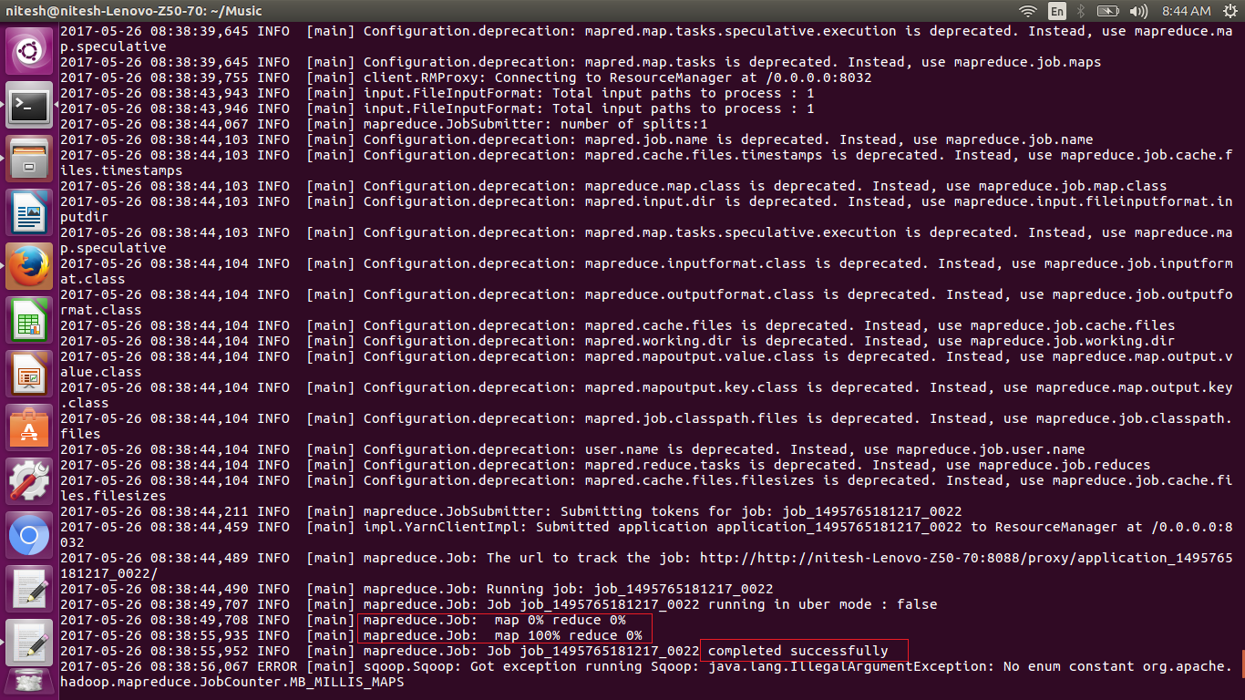

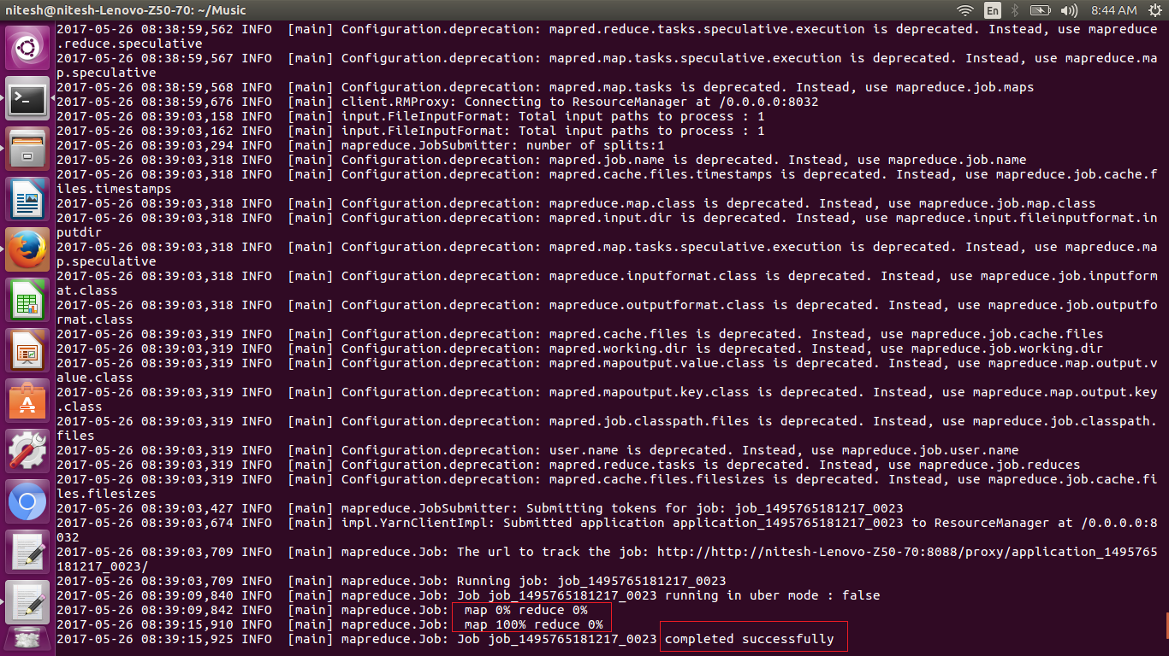

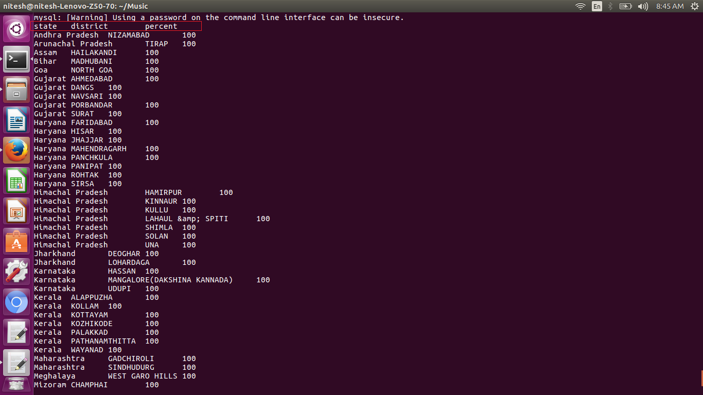

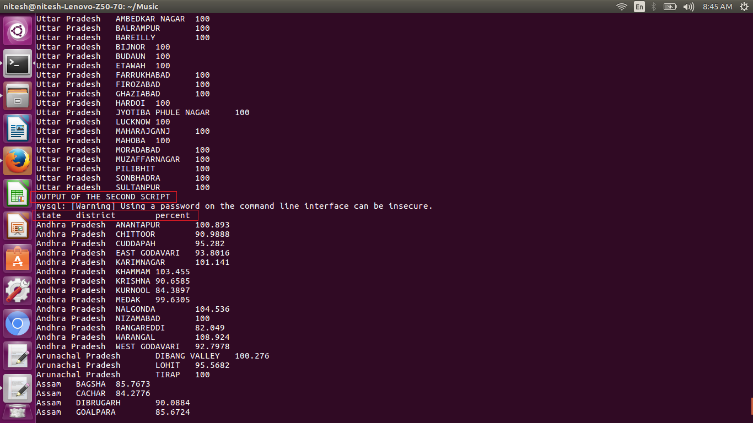

From the above screen shot we can see the eco command is executed and we can separate the results of query1 and query2.

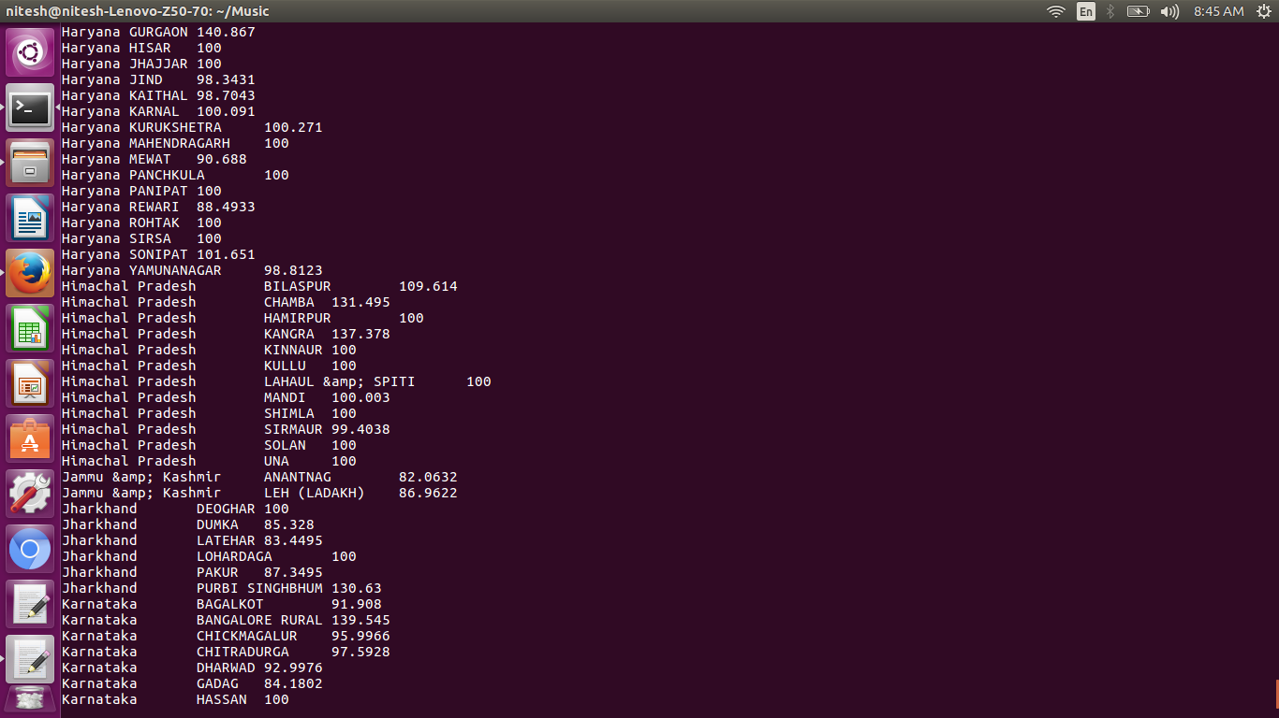

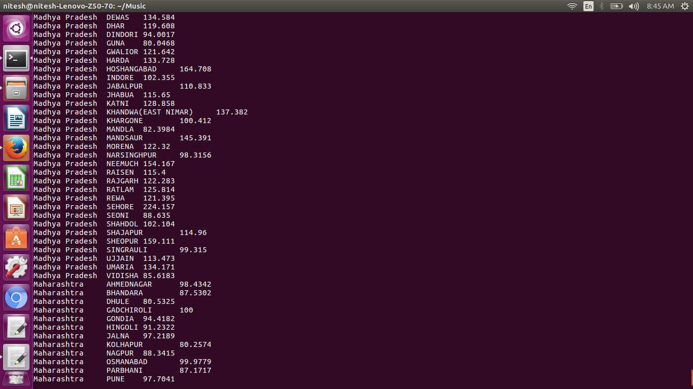

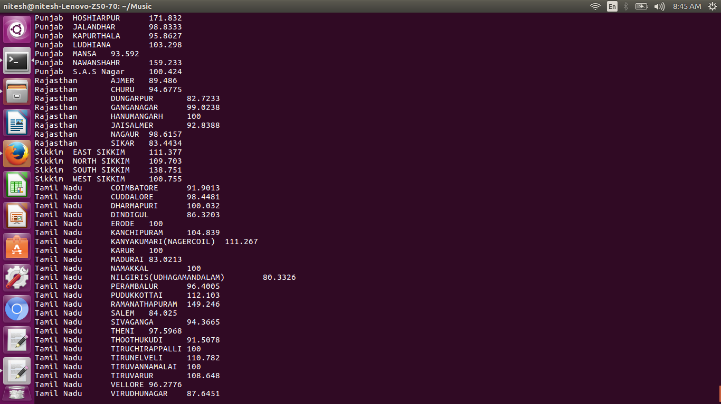

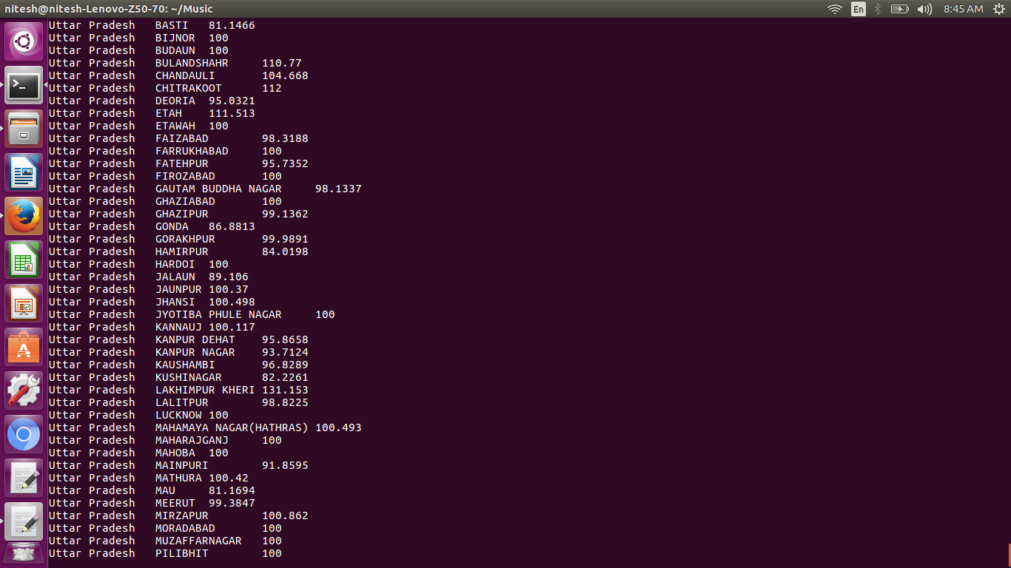

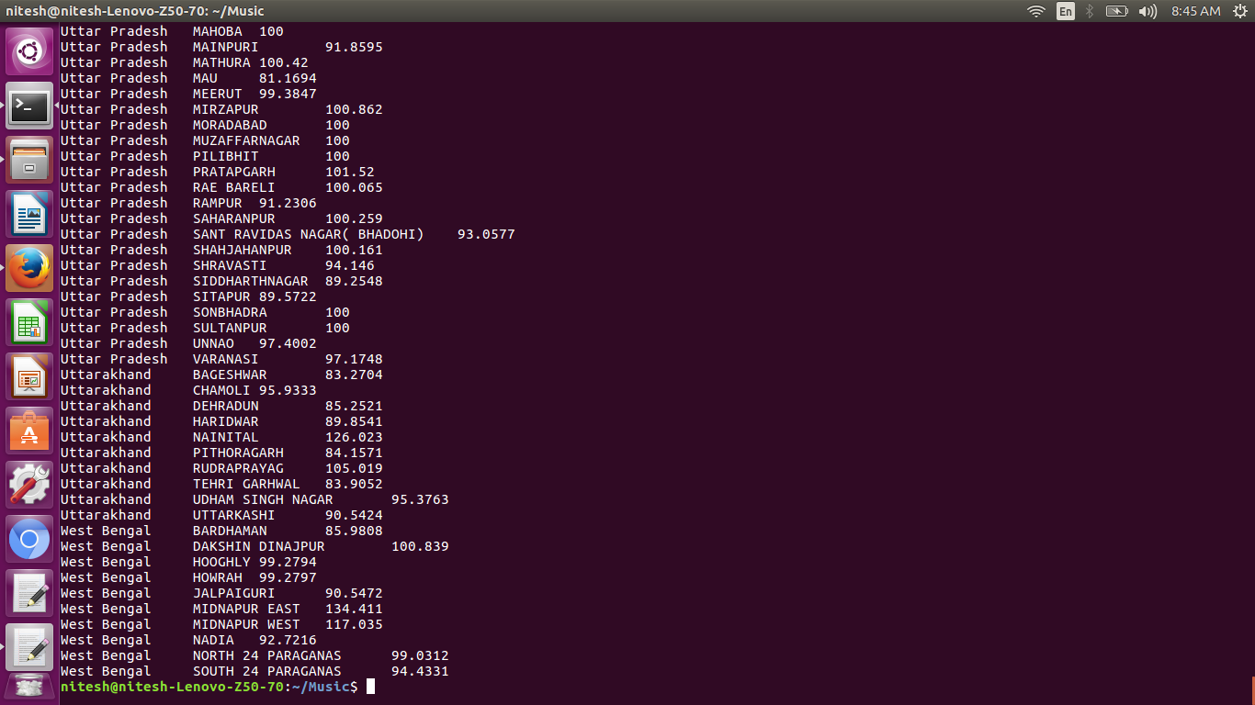

The above screen shots show the results of the second query or problem statement 2